Practical No.1: Prepare a chart of Indian and International Safety Standards

A. Objective :
To study and understand various Indian and International Safety Standards used in industries for ensuring safe working conditions. The objective is to identify important organizations like BIS, OSHA, ISO, and NFPA, and to prepare a chart showing their safety symbols, codes, and applications to promote awareness of industrial safety practices.
B. Expected Program Outcomes (POs):
1. Basic and Discipline Specific Knowledge: Apply knowledge of chemical engineering and safety management principles to understand the role of national and international safety standards in industrial operations.
2. Problem Analysis: Identify and analyse industrial safety issues by referring to relevant safety codes and standard practices.
3. Design/Development of Solutions: Design safe and reliable operating procedures and systems based on Indian and international safety standards to prevent accidents and ensure compliance.
4. Environment and Sustainability: Understand environmental safety standards and implement sustainable industrial practices according to ISO 14001 and national environmental laws.
5. Engineering practices for society, sustainability and environment: Apply appropriate technology in context of society, sustainability, environment and ethical practices.
6. Project Management: Use engineering management principles individually, as a team member or a leader to manage projects and effectively communicate about well-defined engineering activities.
7. Life-long learning: Ability to analyse individual needs and engage in updating in the context of technological changes in the field of engineering.
C. Expected skill to be developed based on Competency:
Use principles of safety & pollution control to operate plants safely, and control pollution within permissible limits in chemical industries.
1. Better communication skill
2. Team work
3. Administrative abilities.
D. Expected Course Outcomes:
CO2: Explain Indian and International Safety standards Practical Outcome:
E. Practical Outcome:
Prepare a chart of Indian and International Safety Standards
F. Prerequisite Theory:
Indian Safety Standards:
In India, safety standards are mainly formulated and regulated by the Bureau of Indian Standards (BIS), which provides various Indian Standards (IS) for industrial safety. Important Indian regulations include the Factories Act, 1948, the Environment Protection Act, 1986, the Explosives Act, and rules for handling hazardous chemicals. BIS issues standards for fire safety, electrical safety, PPE, gas cylinders, pipelines, pressure vessels, and chemical handling. Organizations like the Directorate General Factory Advice Service & Labour Institutes (DGFASLI) and OISD (Oil Industry Safety Directorate) also prepare guidelines for safe operation in oil, gas, and chemical industries. These standards ensure accident prevention, safety training, emergency preparedness, safe equipment design, and employee protection across Indian industries.

International Safety Standards:
International safety standards are developed by global organizations to ensure uniform safety practices across countries. The most commonly followed international standards include ISO (International Organization for Standardization) such as ISO 45001 for Occupational Health and Safety Management Systems, ISO 14001 for Environmental Management, and ISO 9001 for quality systems that indirectly improve safety. Other important bodies include OSHA (Occupational Safety and Health Administration – USA), NFPA (National Fire Protection Association – USA) for fire codes, ANSI, IEC, and ILO (International Labour Organization), which provide standards for electrical safety, fire protection, chemical handling, PPE, and workplace health. These standards help industries manage risks, conduct audits, improve safety performance, and maintain global safety compliance.

ISO- INTERNATIONAL ORGANIZATION FOR STANDARDIZATION
ISO 45001- Occupational Health & Safety Management Systems
Hazard Identification &risk assessment, Legal and regulatory compliance, Incidents investigation and corrective action.

ISO 14001- Environmental Management Systems
Wastewater treatment, Hazardous waste Management, Air Emission Control, Maintaining Environment Clean.
ISO 50001 - Energy Management Systems
Guides organizations in improving energy efficiency and reducing energy costs and emissions.
NFPA (National Fire Protection Association – USA)
Fire and explosion prevention (NFPA 10, NFPA 30, NFPA 70E)
ANSI (American National Standards Institute)
Standards for protective equipment and safe machinery
G. Apparatus / Resources Required:
- Safety standards reference sheets provided by instructor
- Safety symbols chart
- Manual / notebook
- Internet access (if allowed)
- BIS, ISO, IEC, OSHA, NFPA standard excerpts
H. Procedure:
- Collect the list of Indian safety standards from BIS, NBC, and Factories Act.
- Collect the list of international standards from ISO, IEC, OSHA, NFPA.
- Identify scope, purpose, and applications of each standard.
- Prepare a comparison table between Indian and international standards.
- Analyse similarities and differences in safety requirements.
- Write observations and prepare a conclusion.
I. Safety and Precautions:
- Read the practical instructions carefully before beginning the activity.
- Follow all general laboratory safety rules at all times.
- Do not handle any electrical equipment without permission from the instructor.
- Ensure hands are dry while touching switches, plugs, or electrical panels.
- Do not remove or tamper with any safety guards, labels, or warning signs.
- Maintain a safe distance from moving machinery or equipment.
J. Observation :
During the practical, various Indian and international safety standards were studied, including IS codes, ISO, IEC, OSHA and NFPA guidelines. It was observed that Indian standards mainly focus on national industrial requirements, while international standards provide more detailed and globally accepted safety practices. The comparison showed that both sets of standards aim to reduce risks and ensure safe working environments. Indian standards align well with global benchmarks but may differ in depth and scope. Overall, the study helped in understanding the importance and application of safety standards in engineering and industry.
K. Interpretation of result :
Based on the study of various Indian and international safety standards, it is observed that all standards aim to ensure the protection of people, equipment and the working environment. Indian standards such as IS codes, the Factories Act and the National Building Code provide essential safety guidelines that are suitable for national requirements. International standards like ISO, IEC, OSHA and NFPA offer more detailed, globally recognized practices that enhance overall safety performance.
L. Conclusion :
This experiment helped in understanding various national and international safety standards such as IS, BIS, OSHA, NFPA, ISO, and their importance in ensuring safe industrial operations. Preparing the chart improved knowledge of globally accepted safety guidelines and enhanced awareness of regulatory compliance in chemical industries.
M. Practical Related Quiz :
1) Overview of BIS (Bureau of Indian Standards).
The Bureau of Indian Standards (BIS) is the national standards body of India established under the BIS Act. Its primary role is to formulate and maintain Indian Standards (IS) to ensure quality, safety, and reliability of products, services, and systems. BIS covers a wide range of sectors including chemicals, electrical items, mechanical engineering, textiles, food products, and PPE. One of the key functions of BIS is product certification through the ISI mark, which assures consumers that the product is tested and meets safety requirements. BIS also conducts inspections, audits, training programs, and testing through recognized laboratories.
2) Explain ISO 45001.
ISO 45001 is an international standard that specifies requirements for an Occupational Health and Safety Management System (OHSMS). It helps organizations create a safe and healthy workplace by identifying potential hazards, assessing risks, and implementing control measures. The standard follows a risk-based approach and encourages employee participation in safety programs. It includes elements such as safety policy, hazard identification, incident investigation, emergency preparedness, and continuous improvement.
N. Assessment – Rubrics:
Sr No. | Performance Indicators for the PIs | Weightage in % | Actual marks
1 | Understand importance of practical | 20
2 | Prepare report of practical in prescribed format | 30
3 | Solve assignment question | 30
4 | Viva- voce | 20
 | Total | 100

Sign with Date

Practical No.2: Identify different hazards in a given chemical plant

A. Objective:
To systematically identify and classify different hazards in a given chemical plant, including process-related, chemical, mechanical, electrical, and environmental hazards, with the aim of developing awareness about risk factors, improving safety measures, and minimizing the chances of accidents and operational failures.
B. Expected Program Outcomes (POs):
1. Basic and Discipline Specific Knowledge: Apply knowledge of chemical engineering and safety management principles to understand the role of national and international safety standards in industrial operations.
2. Problem Analysis: Identify and analyse industrial safety issues by referring to relevant safety codes and standard practices.
3. Design/Development of Solutions: Design safe and reliable operating procedures and systems based on Indian and international safety standards to prevent accidents and ensure compliance.
4. Environment and Sustainability: Understand environmental safety standards and implement sustainable industrial practices according to ISO 14001 and national environmental laws.
5. Engineering practices for society, sustainability and environment: Apply appropriate technology in context of society, sustainability, environment and ethical practices.
6. Project Management: Use engineering management principles individually, as a team member or a leader to manage projects and effectively communicate about well-defined engineering activities.
7. Life-long learning: Ability to analyse individual needs and engage in updating in the context of technological changes in the field of engineering.
C. Expected skill to be developed based on Competency:
Use principles of safety & pollution control to operate plants safely, and control pollution within permissible limits in chemical industries.
1. Better communication skill
2. Team work
3. Administrative abilities.
D. Expected Course Outcomes:
CO2: Explain Indian and International Safety standards Practical Outcome:
E. Practical Outcome:
Identify different hazards in a given chemical plant
F. Prerequisite Theory:
Petrochemical industry
the petrochemical industry is a sector that produces and trade chemical desired from petroleum and natural gas also known as petrochemical.
Hazard involve in petrochemical industry:
1. Fire and Explosion Hazards
This is the most critical hazard in the petroleum industry due to the flammable nature of crude oil and its derivatives.
- Example :Flammable liquids and vapours:
Petrol, diesel, LPG, and natural gas are easily ignitable.
2. Toxic Chemical Exposure
Workers can be exposed to hazardous substances like hydrogen sulphide, carbon monoxide, and other chemicals through inhalation or skin contact.
3. Mechanical Hazards
The petroleum industry uses heavy and high-speed equipment which poses mechanical dangers.
- Rotating equipment:
Pumps, compressors, and turbines may cause entanglement or crush injuries.
- High-pressure systems:
Pipelines, valves, and vessels may burst or leak if over-pressurized.
- Moving parts and vehicles:
Forklifts, cranes, and trucks in refinery areas can cause accidents.
4. Thermal Hazards
Refining and cracking operations run at very high temperatures.
- Risk of burns:
Contact with hot surfaces like reactors, furnaces, and steam lines.
- Thermal radiation:
Heat waves from furnace units or flare stacks can cause heat stress.
5. Electrical Hazards
- Static electricity.
Flow of flammable liquids generates static charges that can ignite vapours.
- Faulty electrical equipment.
Sparks from motors, switches, or cables can start fires in flammable zones.
G. Apparatus / Resources Required:
- Hazard identification chart
- Chemical safety data sheets (SDS)
- Process flow diagrams of chemical plant (given by instructor)
- Observation sheet
- Safety symbols sheet
H. Safety and Precautions:
- Do not touch any chemical or equipment without permission.
- Always use PPE such as gloves, goggles and safety shoes when required.
- Maintain safe distance from high-temperature and high-pressure equipment.
- Handle chemical containers carefully and avoid inhaling fumes.
- Follow emergency evacuation routes in case of leaks or spills.
- Report any unsafe condition immediately to the instructor.
I. Procedure:
- Study the chemical plant layout or flow diagram provided.
- Identify areas where chemicals are stored, transported or processed.
- Observe equipment such as reactors, boilers, pumps and pipelines.
- List potential hazards based on chemical, physical, mechanical and fire/explosion categories.
- Refer to Safety Data Sheets (SDS) to identify chemical-specific hazards.
- Record observations and classify each hazard type.
- Discuss control measures for each identified hazard.
J. Observation :
During the practical, various hazards present in a chemical plant were identified. Chemical hazards included exposure to toxic and corrosive chemicals such as acids, solvents and gases. Physical hazards were observed in high-temperature equipment, high-pressure systems and noisy areas. Fire and explosion risks were noted near flammable substances and reactors. Mechanical hazards involved rotating machinery and moving equipment. Overall, the study helped understand the wide range of risks present in chemical industries.
K. Interpretation of result :
During the practical, various hazards present in a chemical plant were identified. Chemical hazards included exposure to toxic and corrosive chemicals such as acids, solvents and gases. Physical hazards were observed in high-temperature equipment, high-pressure systems and noisy areas. Fire and explosion risks were noted near flammable substances and reactors. Mechanical hazards involved rotating machinery and moving equipment. Overall, the study helped understand the wide range of risks present in chemical industries.
L. Conclusion :
By identifying various hazards like chemical, physical, mechanical, electrical, and ergonomic hazards, this experiment highlighted the importance of hazard recognition in preventing accidents. It helped develop skills to observe unsafe conditions and understand the necessity of proper controls.
M. Practical Related Quiz :
1. Describe Biological Hazards.
Biological hazards are risks caused by living organisms or their products, which can affect human health. These hazards include bacteria, viruses, fungi, parasites, and biological toxins. In the chemical industry, biological hazards may arise through contaminated raw materials, waste handling, cooling towers, laboratories, or water systems. Workers may be exposed through inhalation, skin contact, or ingestion. Biological hazards can cause infections, allergies, respiratory problems, skin disorders, or long-term illnesses. Proper hygiene, sanitation, disinfection, PPE, and waste management are essential to control these hazards. Biological hazards are particularly dangerous because they may spread easily and may not be immediately visible.
2. List out Physical Hazards.
Physical hazards are environmental factors that can cause harm without necessarily touching a chemical or biological substance. Common physical hazards include noise, vibration, heat, cold, ultraviolet and infrared radiation, ionizing radiation, poor illumination, confined spaces, high-pressure systems, and moving machinery. These hazards can cause injuries like burns, hearing loss, heat stress, frostbite, fractures, and eye damage. Proper engineering controls, PPE, machine guarding, insulation, and safe work practices are essential to control physical hazards.
N. Assessment – Rubrics:
Sr No. | Performance indicators for the PIs | Weightage in % | Actual marks
1 | Understand importance of practical | 20
2 | Prepare report of practical in prescribed format | 30
3 | Solve assignment question | 30
4 | Viva- voce | 20
 | Total | 100

Sign and Date

Practical No.3: Identify chemical hazards in a given plant

A. Objective :
The objective of this practical is to study the chemicals used in a plant and identify the hazards related to their physical and chemical properties. This includes recognizing toxic, corrosive, flammable, reactive, and explosive substances. Understanding these hazards helps students learn proper handling procedures and reduces the chances of chemical-related incidents.
B. Expected Program Outcomes (POs):
1. Basic and Discipline Specific Knowledge: Apply knowledge of chemical engineering and safety management principles to understand the role of national and international safety standards in industrial operations.
2. Problem Analysis: Identify and analyse industrial safety issues by referring to relevant safety codes and standard practices.
3. Design/Development of Solutions: Design safe and reliable operating procedures and systems based on Indian and international safety standards to prevent accidents and ensure compliance.
4. Environment and Sustainability: Understand environmental safety standards and implement sustainable industrial practices according to ISO 14001 and national environmental laws.
5. Engineering practices for society, sustainability and environment: Apply appropriate technology in context of society, sustainability, environment and ethical practices.
6. Project Management: Use engineering management principles individually, as a team member or a leader to manage projects and effectively communicate about well-defined engineering activities.
7. Life-long learning: Ability to analyse individual needs and engage in updating in the context of technological changes in the field of engineering.
C. Expected skill to be developed based on Competency:
Use principles of safety & pollution control to operate plants safely, and control pollution within permissible limits in chemical industries.
1. Better communication skill
2. Team work
3. Administrative abilities.
D. Expected Course Outcomes:
CO2: Explain Indian and International Safety standards Practical Outcome:
E. Practical Outcome:
Prepare a chart of Indian and International Safety Standards
F. Prerequisite Theory:
Chemical hazard in polymer plant:
Raw materials used in this:
1. Ethylene
2. Propylene
3. Catalysts
4. Solvents
Hazard by given raw materials :
1) Ethylene
Chemical Formula: C₂H₄
Chemical Hazards:
Ethylene is a flammable gas. It presents several hazards. It can cause toxicity if inhaled and potential risk of cancer and genetic defects.
Highly flammable, explosion risk, and acts as an asphyxiant at high concentration.
2) Propylene
Chemical Formula: C₃H₆
Chemical Hazards:
Propylene is extremely flammable and explosive.
Frostbite: Contact with liquid or cold gaseous propylene can cause frostbite.
Propylene is corrosive or poisonous gas and may release flammable vapors that can travel long distances and flash back.
3) Catalysts
Chemical Formula: Ziegler–Natta, Metallocene (TiCl₄, ZrCl₄, MAO)
Chemical Hazards:
Flammable, toxic, and moisture-sensitive.
Cause skin and eye irritation.
Eye irritation: Immediately flush eyes with plenty of water.
Symptoms of overexposure:
Possible skin and eye irritation on contact.
Inhalation of vapours in an unventilated area may over time induce headaches or dizziness.
4) Solvents
Chemical Formula: C₆H₁₄ (Hexane)
Chemical Hazards:
Flammable, harmful vapours, skin and eye irritation.
G. Apparatus / Resources Required:
- Plant flow diagram or layout
- Chemical inventory list (given by instructor)
- SDS sheets of chemicals
- Observation sheet and manual
H. Safety and Precautions:
- Always wear appropriate PPE such as gloves, goggles, face mask, and safety shoes while handling chemicals.
- Read and understand the Safety Data Sheet (SDS) of each chemical before use.
- Do not directly inhale fumes or come in contact with corrosive or toxic chemicals.
- Ensure proper ventilation in areas where volatile or flammable chemicals are handled.
- Handle chemical containers carefully and keep them properly labelled and sealed.
- Avoid mixing chemicals without supervision, as unexpected reactions may occur.
I. Procedure:
- Study the given plant layout or process flow diagram.
- Identify areas where chemicals are stored, transported or used in reactions.
- Refer to the SDS of each chemical to understand its hazards.
- Classify the chemicals into toxic, corrosive, flammable and reactive categories.
- Identify chemical leak-prone zones such as pipelines, valves, reactors and storage tanks.
- Record observations and discuss possible preventive measures.
J. Observation :
During the practical, various chemical hazards were identified at different sections of the plant. Chemicals such as acids, solvents and flammable liquids were found to pose risks of toxicity, corrosion and fire. Areas like chemical storage rooms, transfer pipelines and reaction vessels showed potential exposure points. SDS sheets revealed hazards like inhalation toxicity, skin burns and vapor explosion risks. Overall, the study helped understand how different chemicals create varying levels of danger in plant operations.
K. Interpretation of Result :
The analysis shows that chemical hazards in the plant arise mainly due to the presence of toxic, corrosive, flammable and reactive substances. Identifying these hazards enables the implementation of appropriate control measures such as proper ventilation, PPE, safe storage practices and emergency response planning. This ensures safer chemical handling and reduces accident risk.
L. Conclusion :
This experiment provided understanding of chemical hazards such as toxicity, flammability, corrosivity, and reactivity. It emphasized the importance of proper chemical handling, storage, labelling, and the need for MSDS (Material Safety Data Sheets) in ensuring worker safety.
M. practical related quiz :
1. Describe how chemicals enter into the human body.
Chemicals can enter the human body through four main routes:
- Inhalation: Breathing in harmful vapours, gases, aerosols or dust.
- Skin Absorption: Chemicals passing through the skin when it comes in contact.
- Ingestion: Swallowing chemicals accidentally through contaminated hands, food or water.
- Injection: Chemicals entering the body due to cuts, punctures or sharp objects.
2. Define dust and fumes. List out few examples of dust and fumes in the chemical industry.
- Dust: Small solid particles generated by crushing, grinding or handling of solid materials.
- Fumes: Fine solid particles formed when metals or chemicals vaporize and then condense in the air.
Examples of Dust in Chemical Industry:
- Cement dust
- Silica dust
- Coal dust
- Plastic resin dust
- Limestone powder
Examples of Fumes in Chemical Industry:
- Acid fumes (HCl, H₂SO₄)
- Metal fumes (zinc, lead, aluminium)
- Solvent fumes (toluene, benzene)
- Ammonia fumes
- Chlorine fumes
N. Assessment – Rubrics.
Sr No. | Performance Indicators for the PIs | Weightage in % | Actual marks
1 | Understand importance of practical | 20
2 | Prepare report of practical in prescribed format | 30
3 | Solve assignment question | 30
4 | Viva- voce | 20
 | Total | 100

Sign and Date

Practical No.4: Identify colour codes for pipelines used for hazardous chemicals

A. Objective :
Pipe line colour coding is a vital part of industrial colour and band to indicates the type of material flowing through them whether gas , liquid, acid, alkali ,toxic substance.
B. Expected Program Outcomes (POs):
1. Basic and Discipline Specific Knowledge: Apply knowledge of chemical engineering and safety management principles to understand the role of national and international safety standards in industrial operations.
2. Problem Analysis: Identify and analyse industrial safety issues by referring to relevant safety codes and standard practices.
3. Design/Development of Solutions: Design safe and reliable operating procedures and systems based on Indian and international safety standards to prevent accidents and ensure compliance.
4. Environment and Sustainability: Understand environmental safety standards and implement sustainable industrial practices according to ISO 14001 and national environmental laws.
5. Engineering practices for society, sustainability and environment: Apply appropriate technology in context of society, sustainability, environment and ethical practices.
6. Project Management: Use engineering management principles individually, as a team member or a leader to manage projects and effectively communicate about well-defined engineering activities.
7. Life-long learning: Ability to analyse individual needs and engage in updating in the context of technological changes in the field of engineering.
C. Expected skill to be developed based on Competency:
Use principles of safety & pollution control to operate plants safely, and control pollution within permissible limits in chemical industries.
1. Better communication skill
2. Team work
3. Administrative abilities.

D. Expected Course Outcomes:
CO2: Explain Indian and International Safety standards Practical Outcome:
E. Practical Outcome:
Prepare a chart of Indian and International Safety Standards
F. Prerequisite Theory:
Pipe line colour coding
Pipe line colour coding is a vital part of industrial colour and band to indicates the type of material flowing through them whether gas , liquid, acid, alkali ,toxic substance
Indian standards : IS 2379
- Develop by the bureau of Indian standard .uses base colour and colour band to identify the contents
- IS 2379 uses base colour ( to represent of fluid ) and optional colour band
Colour code:
Sr No. | Colour | Chemical | Colour band | Examples
1 | Sky blue | Non-flammable gas | ___ | N2, CO2
2 | Violet | Acid | White | H2SO4
3 | Light green | Alkalis | White | NAOH
4 | Red | Fire water | __ | Fire hydrate line
5 | Grey | Steam | __ | Hot shower
6 | Brown | Flammable liquid | Yellow or silver | Petrol
7 | Bright yellow | Toxic fluid | Black | Ammonia

International pipeline colour coding standard:
ISO-14726:colour coding of pipeline . mainly used for industrial pipeline marking focused on both identification and safety hazard .
Colour code:
Sr No. | Colour | Standard type | Example
1 | Brown | Flammable liquid | Petrol, diesel
2 | orange | Toxic or corrosive fluid | Hydrogen, LPG
3 | yellow | Flammable gas | Hydrogen
4 | Violet | acid | HCL ,H2SO4
5 | Green | alkalis | NAOH ,KOH

American standard :
ANSE ( American society of mechanical engineering ). Widely used in the united states and multination industries.
Colour code:
Sr No. | Colour | Hazard type | Example
1 | yellow | Flammable fluid | LPG , PETROL
2 | Orange | Toxic or corrosive | HCL, H2SO4
3 | RED | fire fluid | GASOLINE, ETHANOL
4 | green | water | Process water
5 | Grey | Steam | High and low pressure

G. Apparatus / Resources Required:
- IS 2379 colour code chart
- Plant piping diagram
- Sample pipeline photographs (given by instructor)
- Observation sheet
H. Safety & Precautions:
- Do not touch or operate valves without permission.
- Maintain safe distance from high-pressure and high-temperature pipelines.
- Observe colour codes carefully and avoid misinterpretation.
- Use PPE when near hazardous chemical lines.
- Report faded, damaged or missing colour markings immediately.
- Follow plant safety signs and instructor guidance.
I. Procedure:
- Study the colour code chart provided by the instructor.
- Observe the plant layout or photographs showing different pipelines.
- Identify the base colour and additional bands/labels on each pipeline.
- Match the observed colour with the IS 2379 standard.
- Note the type of chemical/fluid carried in each pipeline.
- Record the observations in the manual.

J. Observation:
During the practical, different pipeline colours were identified according to IS 2379. Yellow-coloured pipelines indicated flammable liquids or gases, while orange pipelines were used for toxic and corrosive chemicals. Green pipelines carried water and red pipelines were used for fire-fighting systems. Grey pipelines were observed for steam lines and light blue for compressed air. Overall, colour coding helped easily recognize the type of fluid flowing through each pipeline.
K. Interpretation of Result:
The practical showed that pipeline colour coding is essential for safe handling of hazardous chemicals. By identifying standard colours, workers can prevent accidental exposure, avoid wrong valve operation, and respond quickly during emergencies. The use of colour codes enhances overall safety and reduces operational risks in chemical plants.
L. Conclusion:
Learning the pipeline color-coding system improved understanding of how industries communicate material hazards visually. Identifying and interpreting colour codes helps prevent operational errors and supports safe maintenance and emergency handling.
M. Practical Related Quiz:
1. What is the use of colour codes for pipelines used in the chemical industry?
Colour codes on pipelines are used to quickly identify the type of chemical or fluid flowing through the pipeline. This helps workers avoid accidental contact, prevents wrong valve operations, and improves safety during maintenance and emergencies. Colour coding allows easy recognition of hazardous chemicals, reduces the risk of fire, explosion or poisoning, and ensures smooth and safe plant operations.
2. Write Colour codes for flammable, combustible, toxic or corrosive chemicals (as per IS 2379).
- Flammable Chemicals / Flammable Liquids or Gases → Yellow
- Combustible Liquids → Black
- Toxic or Corrosive Chemicals → Orange

N. Assessment – Rubrics:
Sr no | Performance indicators for the PIs | Weightage in % | Actual marks
1 | Understand importance of practical | 20
2 | Prepare report of practical in prescribed format | 30
3 | Solve assignment question | 30
4 | Viva- voce | 20
 | Total | 100

Sign and Date

Practical No.5: Identify colour code for gas cylinders.

A. Objective :
The objective of this practical is to study the prescribed colour coding system for different types of industrial gas cylinders. By identifying these colour codes, students learn to distinguish between oxygen, nitrogen, LPG, CO₂, and other gases. This knowledge helps in preventing accidental misuse and ensures proper storage, handling, and transportation of gas cylinders.
B. Expected Program Outcomes (POs):
1. Basic and Discipline Specific Knowledge: Apply knowledge of chemical engineering and safety management principles to understand the role of national and international safety standards in industrial operations.
2. Problem Analysis: Identify and analyse industrial safety issues by referring to relevant safety codes and standard practices.
3. Design/Development of Solutions: Design safe and reliable operating procedures and systems based on Indian and international safety standards to prevent accidents and ensure compliance.
4. Environment and Sustainability: Understand environmental safety standards and implement sustainable industrial practices according to ISO 14001 and national environmental laws.
5. Engineering practices for society, sustainability and environment: Apply appropriate technology in context of society, sustainability, environment and ethical practices.
6. Project Management: Use engineering management principles individually, as a team member or a leader to manage projects and effectively communicate about well-defined engineering activities.
7. Life-long learning: Ability to analyse individual needs and engage in updating in the context of technological changes in the field of engineering.
C. Expected skill to be developed based on Competency:
Use principles of safety & pollution control to operate plants safely, and control pollution within permissible limits in chemical industries.
1. Better communication skill
2. Team work
3. Administrative abilities.
D. Expected Course Outcomes:
CO2: Explain Indian and International Safety standards Practical Outcome:
E. Practical Outcome:
Prepare a chart of Indian and International Safety Standards
F. Prerequisite Theory:
Gas cylinders are colour codes to indicate the type of gas they contain and the associated hazard. The shoulder of the cylinder is typically the area where colour coding applied.
Objective:
- Hazard identification : Different colour provide a visual clue about the gases potential hazard such as flammability , toxicity, or oxidizing properties allowing for proper handling.
- Quick identification :
Colour code enable rapid identification of gas without needing to read labels, especially use for in busy environment or when handling multiple cylinder.
- There are three standard for gas cylinder codes.
- ISO 32
- IS 4379
- ANSI Z 48.1
ISO 32: COLOUR CODE:
Sr No. | Gas | Shoulder colour
1 | Oxygen | White
2 | Hydrogen | Red
3 | Carbon dioxide | Grey
4 | Nitrogen | Black
5 | Air | Light green
6 | Helium | Brown
7 | Chlorin | Yellow
8 | Argon | Dark green
9 | Ammonia | Blue
10 | Medical oxygen | White shoulder

IS 4379:
Sr No. | Gas name | Cylinder body colour | Cylinder shoulder colour | Uses/properties
1 | Oxygen | Black | White | Support combustion
2 | Hydrogen | Red | Red | Flammable gas
3 | Nitrogen | Black | Grey | Inert gas
4 | Carbon dioxide | Maroon | Grey | Inert gas
5 | Acetylene | Black | Maroon | Highly flammable
6 | Air | Brown | Green | Respiratory use
7 | Helium | Brown | Brown | Inert gas
8 | Argon | Dark green | Dark green | Inert gas
9 | Ammonia | White | Yellow | Toxic and corrosive gas
10 | Chlorine | Yellow | Yellow | Toxic gas

ANSI Z 48.1:
Sr No. | Gas | Colour code
1 | Oxygen | Green
2 | Acetylene | Maroon
3 | Hydrogen | Red
4 | Nitrogen | Black
5 | Air | Yellow

G. Apparatus / Resources Required:
- Gas cylinder colour code chart
- Sample cylinder photographs or plant visit
- Observation sheet
H. Safety and Precautions:
- Never use or lift a cylinder without proper training.
- Keep cylinders upright and secured with clamps or chains.
- Do not drop or roll cylinders on the floor.
- Keep flammable gas cylinders away from sparks or heat sources.
- Ensure cylinder valve caps are in place during transport.
- Check labels and colour codes before connecting a cylinder.
- Report damaged or rusted cylinders immediately.
I. Procedure:
- Observe the gas cylinders provided or shown in images.
- Note the cylinder body colour and shoulder/band colour.
- Refer to the gas cylinder colour code chart (IS 4379).
- Identify the type of gas corresponding to each colour code.
- Record the observations clearly in the manual.
J. Observation:
During the practical, different gas cylinders were identified using their colour codes. Oxygen cylinders were recognized by black bodies with white shoulders, while acetylene cylinders had maroon bodies. Nitrogen and carbon dioxide cylinders showed grey colouring, and hydrogen cylinders were observed in red. The colour coding helped differentiate between flammable, oxidizing, inert and toxic gases effectively.
K. Interpretation of Result:
The practical showed that gas cylinder colour codes enable quick and accurate identification of gases, ensuring safe handling. Correct identification helps prevent accidental mixing or misuse of gases and reduces risks such as fire, explosion or toxicity.
  - Conclusion :
This experiment reinforced the importance of gas cylinder identification using standard colour codes. It ensures safe storage, handling, and usage of gases by reducing the risk of confusion, leakage hazards, or accidental mixing of incompatible gases.
M. Practical Related Quiz :
1. Explain the procedure of colouring patterns for gas cylinders.
- Cleaning the Cylinder Surface:
The cylinder is first cleaned thoroughly to remove dust, rust, grease, or old paint. Sandblasting or wire brushing is commonly used.
- Application of Base Colour:
A base coat is applied over the entire cylinder body according to the standard colour code (as per IS 4379 / ISO guidelines). This forms the main identifying colour.
- Painting the Shoulder/Band:
The cylinder shoulder (top portion) or colour band is painted with a specific colour that indicates the type of gas. This is the primary identification marking for the gas content.
- Adding Labels and Stencils:
The name of the gas, pressure rating, hazard symbols and test dates are stencilled or printed on the cylinder. These markings must be clear and permanent.
- Inspection and Drying:
The cylinder is inspected to ensure that the colour coding and markings are correct and uniform. The paint is allowed to dry completely.
- Final Verification:
The cylinder is verified by a trained inspector before being filled and sent for industrial use.
2. Give the colour codes for following gas cylinder: Nitrogen, CO2, Flammable mixtures, Oxygen, Hydrogen.
1. Nitrogen Cylinder
Colour Code: Grey body with Black shoulder
2. Carbon Dioxide (CO₂) Cylinder
Colour Code: Grey body
3. Flammable Gas Mixtures
Colour Code: Red body (indicates flammable gases like LPG, Hydrogen mixtures, etc.)
4. Oxygen Cylinder
Colour Code: Black body with White shoulder
5. Hydrogen Cylinder
Colour Code: Red body
N. Assessment – Rubrics:
Sr No. | Performance indicators for the PIs | Weightage in % | Actual marks
1 | Understand importance of practical | 20
2 | Prepare report of practical in prescribed format | 30
3 | Solve assignment question | 30
4 | Viva- voce | 20
 | Total | 100

Sign and Date
Practical No.6: identify different safety symbols used in chemical industry.

  - Objective :
The objective of this practical is to observe, identify, and understand the meaning of various safety symbols used in the chemical industry. These include warning signs, mandatory signs, prohibition signs, and emergency signs. The aim is to help students understand how visual symbols promote safe behaviour and hazard communication at workplaces.
B. Expected Program Outcomes (POs):
1. Basic and Discipline Specific Knowledge: Apply knowledge of chemical engineering and safety management principles to understand the role of national and international safety standards in industrial operations.
2. Problem Analysis: Identify and analyse industrial safety issues by referring to relevant safety codes and standard practices.
3. Design/Development of Solutions: Design safe and reliable operating procedures and systems based on Indian and international safety standards to prevent accidents and ensure compliance.
4. Environment and Sustainability: Understand environmental safety standards and implement sustainable industrial practices according to ISO 14001 and national environmental laws.
5. Engineering practices for society, sustainability and environment: Apply appropriate technology in context of society, sustainability, environment and ethical practices.
6. Project Management: Use engineering management principles individually, as a team member or a leader to manage projects and effectively communicate about well-defined engineering activities.
7. Life-long learning: Ability to analyse individual needs and engage in updating in the context of technological changes in the field of engineering.
C. Expected skill to be developed based on Competency:
Use principles of safety & pollution control to operate plants safely, and control pollution within permissible limits in chemical industries.
1. Better communication skill
2. Team work
3. Administrative abilities.
D. Expected Course Outcomes:
CO2: Explain Indian and International Safety standards Practical Outcome:
E. Practical Outcome:
Prepare a chart of Indian and International Safety Standards
F. Prerequisite Theory:
GHS symbols are also known as GHS pictogram are standardize hazard symbols used in the globally harmonized system of classification and labelling if chemical to visually communicate the hazard of chemical they are necessary for providing a clear , universal warning system that can be understood regardless of language or location , improving safety in handling storage and use of hazards material .
PICTOGRAM OR DESCRIPTION:
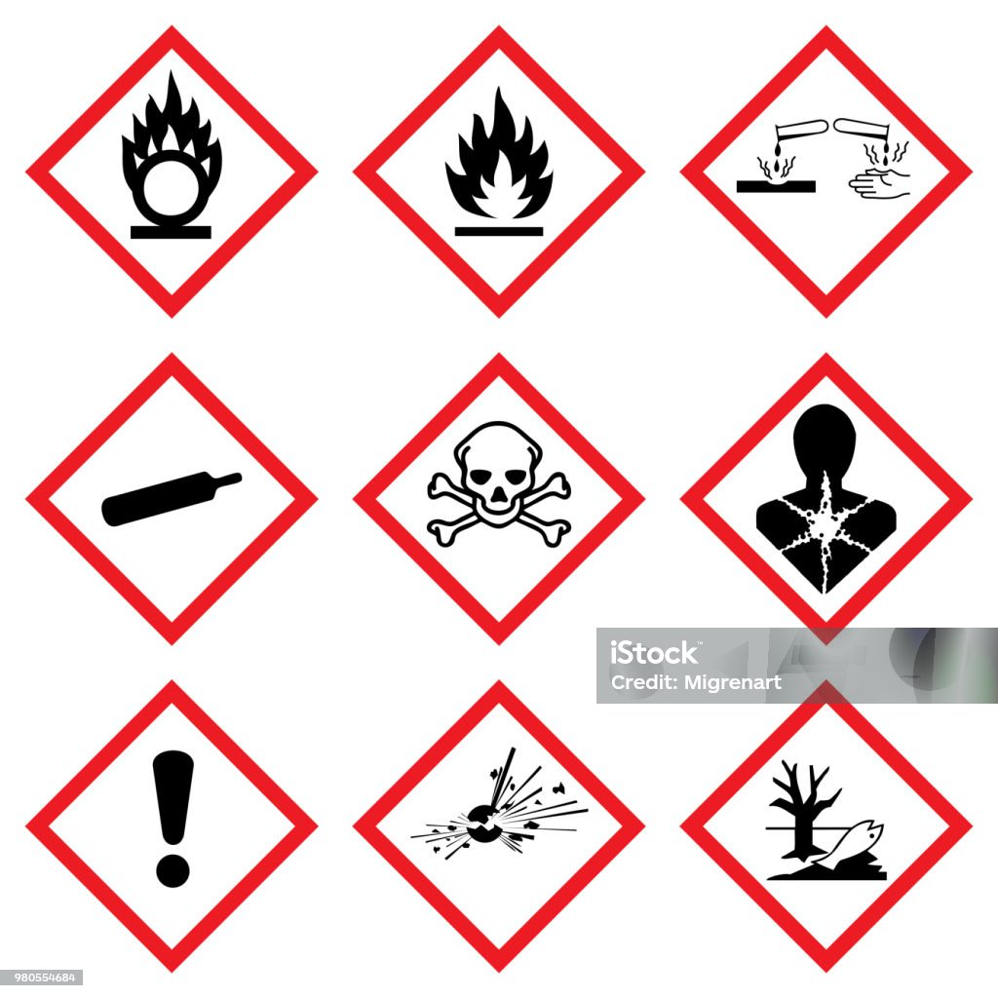
- Health Hazards :- A cancer-causing agent or substance with respiratory toxicity that causes damage over time.


- Flame :- Flammable materials or substances liable to igniter when exposed to water or air, when emit flammable gas.


3. Exclamation mark :- An immediate skin, eye or respiratory trad irritant or narcotic.


4.Gas cylinder :- Gases stored under pressure, liquified gases and dissolved gases such as ammonia, liquid nitrogen or acetylene.


5. Corrosion :- Materials causing skin corrosion/burns or eye damage on contact or that are corrosive to metal.


6. Exploding Bomb:- Explosives including organic peroxides and highly unstable material at risk of exploding even without exposure to air.


7. Skull and Crossbones:- Substances such as poison and highly concentrated acids, which have an immediate and severe toxic effect.

8. Environmental Hazard :- Chemical toxic to aquatic wildlife.


Physical hazardous material classification charts :-
Class 1 | Explosive
Class 2 | Gases
Class 3 | Flammable liquid
Class 4 | Flammable solid
Class 5 | Oxidizer
Class 6 | Toxic material
Class 7 | Radioactive material
Class 8 | Corrosive material
Class 9 | Miscellaneous dangerous good

WHMIS SYMBOLS
The workplace hazardous material information system update the globally harmonized system, of classification or labelling of chemical . it is a Canadian symbol..
1. Flammable gases, aerosols, flammable liquids, flammable solids:
Products ignite or explode easily when exposed to heat, sparks or flame.
2. Oxidizing liquids, solids, gases:
Products that are classified as oxidizers & can cause or intensify a fire or explosion.
3. Gases under pressure:
Products in this class include compressed, liquefied, dissolved & refrigerated gases. Stored in pressurized containers may explode.
4. Self-reactive mixtures & substances:
These products can cause a fire or react on their own. Thermally unstable, explode without air.
5. Pyrophoric liquids and solids:
These products catch fire spontaneously if exposed to air.
6. Self-heating substances and mixtures:
These are products that may catch fire if exposed to air or generate heat by themselves; may catch fire in bulk.
HEALTH HAZARD:
1.Acute toxicity: Harmful if swallowed, inhaled, or absorbed through skin (short-term).
2. Skin corrosion or irritation : Causes burns, damage to skin, or irritation.
3. Serious eye damage or eye irritation :Causes serious or permanent eye injury.
4. Respiratory or skin sensitization : Causes breathing problems, allergies, or skin reactions.
5. Germ cell mutagenicity : May cause genetic defects; passed to future generations.
6. Carcinogenicity : May cause cancer.
7. Reproductive toxicity : Harms fertility, pregnancy, or unborn children.
8. Specific target organ toxicity : single exposure Damage particular organs from one-time exposure.
9. Specific target organ toxicity – repeated exposure
Damage organs after repeated or long-term exposure.
10. Aspiration hazard Can enter lungs (after swallowing/vomiting) and cause severe damage.
11. Biohazardous infectious materials Contain organisms/toxins that cause infections or disease.

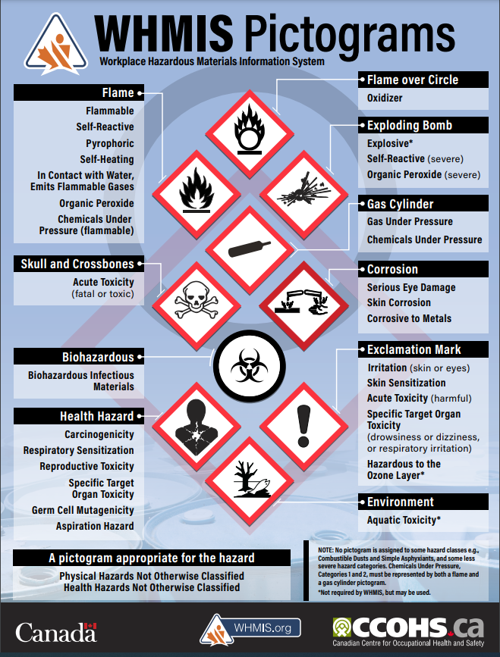

G. Apparatus / Resources Required:
- Safety symbol chart
- Chemical plant layout
- Observation sheet
H. Safety and Precautions:
- Pay close attention to all safety signs in the plant.
- Do not ignore warning or prohibition symbols.
- Use PPE wherever mandatory symbols are displayed.
- Follow emergency symbols in case of accidents.
- Report faded or damaged symbols immediately.
I. Procedure:
- Study the safety symbol chart provided in the lab.
- Observe the symbols shown on equipment, pipelines and plant walls.
- Identify the category each symbol belongs to.
- Note the meaning and usage of each symbol.
- Record observations in the manual.
J. Observation:
During the practical, various safety symbols used in chemical industries were identified. Hazard symbols such as flammable, toxic and corrosive were found near chemical storage areas and reactors. Mandatory symbols like “Wear goggles” and “Wear gloves” were observed in handling and mixing sections. Prohibition symbols like “No smoking” were found near flammable zones. Emergency symbols such as eyewash stations and exits were also easily identifiable.
K. Interpretation of Result:
The study revealed that safety symbols play a crucial role in preventing accidents by clearly indicating hazards, required PPE and emergency equipment. Understanding these symbols allows workers to respond safely and appropriately in chemical processing areas.
L. Conclusion:
Understanding safety symbols improved awareness of workplace hazards and safe practices. This experiment helped in quick recognition of warning, prohibition, mandatory, and emergency symbols, which enhances communication and accident prevention.
M. Practical Related Quiz:
1. List out GHS Safety Symbols.
The Globally Harmonized System (GHS) uses standardized pictograms to classify and communicate chemical hazards. The main GHS symbols are:
- Explosive (Exploding bomb)
- Flammable (Flame)
- Oxidizing (Flame over circle)
- Compressed Gas (Gas cylinder)
- Corrosive (Corrosion to metal/skin)
- Toxic (Skull and crossbones)
- Health Hazard (Person with star on chest – carcinogen, sensitizer)
- Harmful/Irritant (Exclamation mark)
- Environmental Hazard (Dead fish & tree)
2. What is the advantages of safety symbols in chemical industries?
• Quick Hazard Identification: Workers can instantly understand dangers without needing detailed text.
• Prevents Accidents: Helps avoid exposure to toxic, flammable, corrosive or reactive chemicals.
• Universal Understanding: Standard symbols (GHS) are recognized internationally, reducing confusion.
• Improves Workplace Safety: Promotes safe handling, storage and transport of chemicals.
• Supports Emergency Response: Guides workers during spills, leaks, or fire situations.
• Ensures Legal Compliance: Helps industries comply with national and international safety regulations.
N. Assessment – Rubrics:
Sr No. | Performance Indicators for the PIs | Weightage in % | Actual marks
1 | Understand importance of practical | 20
2 | Prepare report of practical in prescribed format | 30
3 | Solve assignment question | 30
4 | Viva- voce | 20
 | Total | 100

Sign and Date

Practical No.7: Demonstrate personal protective equipment for safety

A. Objective:
The objective of this practical is to familiarize students with different types of Personal Protective Equipment (PPEs) such as helmets, gloves, face shields, safety goggles, respirators, and protective clothing. By demonstrating their proper selection, use, and maintenance, students develop skills necessary to ensure personal safety while working in hazardous environments.
B. Expected Program Outcomes (POs):
1. Basic and Discipline Specific Knowledge: Apply knowledge of chemical engineering and safety management principles to understand the role of national and international safety standards in industrial operations.
2. Problem Analysis: Identify and analyse industrial safety issues by referring to relevant safety codes and standard practices.
3. Design/Development of Solutions: Design safe and reliable operating procedures and systems based on Indian and international safety standards to prevent accidents and ensure compliance.
4. Environment and Sustainability: Understand environmental safety standards and implement sustainable industrial practices according to ISO 14001 and national environmental laws.
5. Engineering practices for society, sustainability and environment: Apply appropriate technology in context of society, sustainability, environment and ethical practices.
6. Project Management: Use engineering management principles individually, as a team member or a leader to manage projects and effectively communicate about well-defined engineering activities.
7. Life-long learning: Ability to analyse individual needs and engage in updating in the context of technological changes in the field of engineering.
C. Expected skill to be developed based on Competency:
Use principles of safety & pollution control to operate plants safely, and control pollution within permissible limits in chemical industries.
1. Better communication skill
2. Team work
3. Administrative abilities.
D. Expected Course Outcomes:
CO2: Explain Indian and International Safety standards Practical Outcome:
E. Practical Outcome:
Prepare a chart of Indian and International Safety Standards
F. Prerequisite theory:
PPE - Personal Protective Equipment which is specialized clothing or equipment worn to protect the wearer from injury or infection. It is used in various settings to shield against physical, electrical, chemical, biohazards, and airborne particulate matter hazards. Examples include gloves, hard hats, respirators, safety glasses, and full body suits.
1.Head & Hair Protection: Head protectors are hard hats, caps and helmets. made of PVC fibre glass, laminated Vulcanised fibre. They may be fitted with brackets for firing welding masks, protective face screens.
Sr No. | Type | Protects against
1 | Safety helmet | Falling objects, hitting against obstructions
2 | Electrical safety helmet | Falling objects, hitting against obstructions
3 | Welding cap | Falling welding spatters from above.
4 | Crash helmet | Skull injuries in road accidents.

2. Hand Protection: Protection of hands & arms are required when workers have to handle materials having sharp end, sharp edges, hot and molten metal, chemicals etc.
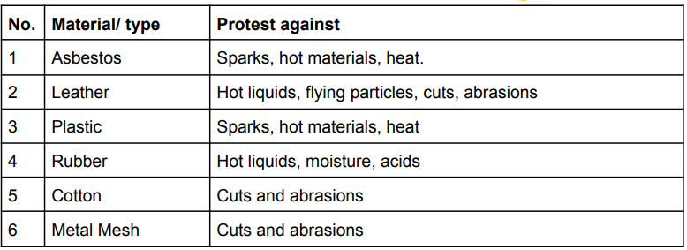

3.Face and Eye Protection: Eye injuries can be caused by mechanical, chemical, thermal and radiation hazards such as flying particles, harmful radiation. Eye protectors cone safety spectacles, impact goggles, welding goggles, foundry goggles, goggles etc.

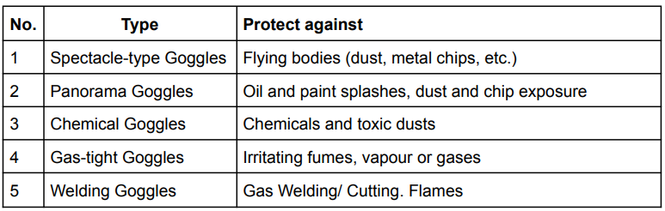

4.Ear Protection : - Noise level above 90dBA is hazardous for an exposure more than 80hr/day or 48 hr/week. It may cause deafness, irritation, fatigue.
Type available:
1.) Ear muffs, or cups
2.) Plugs or insert
3) Dielectric car muff
4) Formable Aural Inserts
5) Full enclosure
6) canal cap.
5.Foot and Leg Protection: Common foot and leg protective equipment are safety shoes, legging and footguards
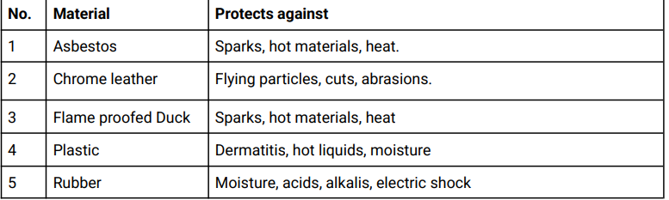

G. Apparatus / Resources Required:
- Set of PPE (helmet, gloves, goggles, apron, mask, shoes)
- Safety demonstration chart
- Observation sheet
H. Safety and Precautions:
- Always inspect PPE before use for any damage.
- Select PPE according to the type of hazard.
- Wear PPE properly; do not modify or misuse it.
- Clean and store PPE after use.
- Replace damaged or expired PPE immediately.
- Follow instructor guidance while demonstrating PPE.
I. Procedure:
- Select the appropriate PPE required for a particular task (chemical handling, mixing, maintenance, etc.).
- Demonstrate the correct way to wear head protection (helmet).
- Demonstrate the proper method of wearing gloves and goggles.
- Wear apron or body suit designed for chemical protection.
- Show the technique of wearing a dust mask or respirator.
- Explain the purpose of safety shoes and how to check them.
- Observe and record the PPE demonstration.
J. Observation:
During the practical, different PPE items such as helmets, gloves, goggles, masks and safety shoes were demonstrated. Each PPE item was shown with its proper wearing method and purpose. Gloves and goggles were used for chemical handling, masks for respiratory protection and helmets for head safety. The demonstration helped understand how each PPE reduces risk in hazardous work situations.
K. Interpretation of Result:
The practical showed that PPE plays a vital role in preventing injuries and chemical exposure. Proper selection and correct wearing techniques are essential to ensure full protection. PPE significantly reduces risks and enhances overall safety in the workplace.
L. Conclusion:
The demonstration of PPE highlighted the role of protective equipment in minimizing exposure to workplace hazards. It provided practical knowledge of selecting, using, and maintaining PPE such as gloves, helmets, goggles, respirators, and safety shoes for industrial safety
M. Practical Related Quiz:
1. Classify PPE.
PPE (Personal Protective Equipment) can be classified into the following categories:
1. Head Protection
- Safety helmets
- Bump caps
2. Eye and Face Protection
- Safety goggles
- Face shields
- Chemical splash goggles
3. Hearing Protection
- Ear plugs
- Ear muffs
4. Respiratory Protection
- Dust masks
- Cartridge respirators
- SCBA
5. Hand Protection
- Chemical-resistant gloves
- Cut-resistant gloves
- Heat-resistant gloves
6. Body Protection
- Lab coats
- Chemical aprons
- Full-body suits
7. Foot Protection
- Safety shoes
- Gumboots
- Chemical-resistant boots
8. Fall Protection
- Safety harness
- Safety belts

2. What is the BIS Standard for Eye Protection and Foot Protection?

BIS Standard for Eye Protection
IS 5983 – Eye Protectors

BIS Standard for Foot Protection
IS 15298 – Safety Footwear for Professional Use
N. Assessment – Rubrics:
Sr No. | Performance Indicators for the PIs | Weightage in % | Actual marks
1 | Understand importance of practical | 20
2 | Prepare report of practical in prescribed format | 30
3 | Solve assignment question | 30
4 | Viva- voce | 20
 | Total | 100

Sign and date

Practical No.8: Prepare a handout on safe handling practices for hazardous chemical.

  - Objective:
The objective of this practical is to prepare a comprehensive handout that highlights safe handling procedures for hazardous chemicals. This includes storage guidelines, PPE usage, labelling requirements, spill control measures, and emergency response steps. The aim is to promote awareness and educate others on minimizing risks associated with hazardous materials.
B. Expected Program Outcomes (POs):
1. Basic and Discipline Specific Knowledge: Apply knowledge of chemical engineering and safety management principles to understand the role of national and international safety standards in industrial operations.
2. Problem Analysis: Identify and analyse industrial safety issues by referring to relevant safety codes and standard practices.
3. Design/Development of Solutions: Design safe and reliable operating procedures and systems based on Indian and international safety standards to prevent accidents and ensure compliance.
4. Environment and Sustainability: Understand environmental safety standards and implement sustainable industrial practices according to ISO 14001 and national environmental laws.
5. Engineering practices for society, sustainability and environment: Apply appropriate technology in context of society, sustainability, environment and ethical practices.
6. Project Management: Use engineering management principles individually, as a team member or a leader to manage projects and effectively communicate about well-defined engineering activities.
7. Life-long learning: Ability to analyse individual needs and engage in updating in the context of technological changes in the field of engineering.
C. Expected skill to be developed based on Competency:
Use principles of safety & pollution control to operate plants safely, and control pollution within permissible limits in chemical industries.
1. Better communication skill
2. Team work
3. Administrative abilities.
D. Expected Course Outcomes:
CO2: Explain Indian and International Safety standards Practical Outcome
E. Practical Outcome:
Prepare a chart of Indian and International Safety Standards
F. Prerequisite Theory:
Solids:
Solid materials are stored in open or covered storage vessels or in drums and bags and stored in warehouses. Mechanical handling facilities for such purposes include conveyors, elevators, gantries, mobile power trucks etc. Powder or granular material can be conveyed by pneumatic conveying and fluidisation.
Liquids:
Liquids are stored in drums, tankers and through small quantities can be stored in carboys, bottles etc. Drum storage areas should be adequately ventilated. Proper type of electrical and lighting fixtures should be provided if material in drums is flammable.
Gas Storage:
Gas holders are used for low pressure gas storage. The factories act mandates that gas holders should be properly designed, fabricated and finally inspected by a competent person. External and internal examination should be done periodically as laid down and repairs should be carried out under the supervision of a competent person. Details of gas holders and results of periodic inspection should be recorded periodically.

Storage and Handling of Liquids
1. Portable containers such as drums, barrels and carboys should be stored and handled carefully.
2. Storage room should have impervious walls and floors and provision for safe disposal of spillage. Before handling, check corrosion or weakening of packing by chemicals.
3. Properly designed carboy indicators are also satisfactory. Before filling, empty carboys should be thoroughly drained and stopper replaced.
Flammable Liquids
1. Take care of adverse weather conditions.
2. Ensure safe access of keep of the calibration tank.
3. Suitable fire extinguishers should be available in the receiving tank.
4. Avoid mixing of chemicals.
Storage and Handling of Gas Cylinders
1. Cylinders may be rolled on the bottom edge but never dragged.
2. Carry cylinders in the cradle or in a suitable type of carrying device.
3. Do not permit them to strike each other violently. Tie vertical cylinders by chain.
4. While refitting empty cylinders or when not in use, close the valve and replace valve protection cap.
Flammable Gases
1. Cylinders should not be dropped, dragged, rolled on their side or permitted to strike another surface violently.
2. Removable caps are provided for valve protection. Such caps should be in place at all times except when cylinders are in use.
3. Use a suitable truck to move them even through short distances.
4. Rooms for cylinders should be dry, cool and ventilated.
Handling and Storage of Solids / Hazardous Materials
1. Dangerous substances should be handled and stored under the supervision of a competent person who is familiar with the risks and precautions.
2. In case of doubt as to the nature of the risk or the precautions to be taken, necessary instructions should be obtained from MSDS and competent authority.
3. When highly flammable material is being handled, special measures should be taken to ensure that an incipient fire can be controlled immediately.
4. When dangerous substances are to be handled or stored, workers concerned should be given adequate information regarding their nature.
Flammable Solids
1. Many solid materials used in industries present fire risk.
2. Some materials generate heat and ignite simultaneously.
3. Certain solids release flammable gases on contact with water.
4. Handling and storage require not only normal precautions but also special safety measures to prevent severe fire hazards.

Handling of Corrosive Chemicals
1. Hazards of corrosive chemicals:
Cause severe damage to living tissues
Can damage/destroy materials on contact.
2. Some additional hazards include toxicity and flammability.
Storage Area Requirements
1. Cool, dry, ventilated area away from heat and occupied buildings.
2. Non-combustible construction; preferred ground floor location.
3. Two exits; fire resistance of building should be suitable.
4. Ventilation system must be available.
Cylinder Homes
1. Keep upright, on a continuous rail above floor.
2. Not stacked more than one high.
3. Separate filled and empty cylinders.
Handling and Storage of Ammonia
Indoor Storage
1. Storage should be cool, dry, well-ventilated and protected from external heat sources.
2. The building with automatic sprinklers, vapour-tight electrical equipment, good natural ventilation, good floor drainage and adequate explosion venting.
Outdoor Storage
1. The location should be away from any flammable liquid storage.
Bulk Storage
1. In case of multiple storage facilities, a plan should be prepared for reading and identifying all shut-off valves used for isolating various parts of the storage facilities.
2. Each storage area should be protected at least by one standard fire hydrant.
3. Gauge glasses should be provided with excess-flow check valves. The gauge glasses should not be longer than 120 cm and more than 60 cm between.
4. Storage tank construction should be of high integrity and double-wall type known as "can in tank" type.
5. Install remote controlled valves at the bottom of ammonia storage tank.
Handling and Storage of LPG
After chlorine and ammonia, the third chemical of major industrial use is LPG i.e. petroleum gas. LPG (propane and butane) are widely used as fuels. LNG (liquefied natural gas) is mainly methane and is stored as liquid and transported by high-pressure pipelines for industrial and domestic use. LPG take-offs are mainly through propane butane cylinders.
Transportation
Railroad Transportation
The preventive measures are:
1. Improved design of the tank cars and couplers.
2. Limitation of the size of the tanks.
3. Positioning of hazardous chemicals away from the locomotive.
4. Avoid hunching together hazardous chemicals.
5. Proper labelling of contents and the hazardous nature of the chemicals.
G. Apparatus / Resources Required:
- Safety Data Sheets (SDS)
- PPE (gloves, goggles, apron, mask)
- Spill kit
- Chemical containers
- Safety symbols chart
H. Safety and Precautions:
- Always wear appropriate PPE before handling chemicals.
- Never smell or touch chemicals directly.
- Use fume hoods for volatile or toxic substances.
- Do not mix chemicals unless instructed.
- Keep containers sealed and properly labelled.
- Clean spills immediately using spill kits.
- Wash hands after handling chemicals.
- Follow emergency procedures during leaks or accidents.

I. Procedure:
- Read the SDS of the given chemical.
- Identify the hazards using GHS symbols.
- Select proper PPE based on chemical hazard type.
- Demonstrate safe handling during pouring, mixing, or transferring chemicals using funnels/pumps.
- Demonstrate safe storage by placing chemicals in proper hazard-class areas.
- Show the correct way to clean a small spill using a spill kit.
- Dispose chemical waste using designated waste containers.
- Record observations in the manual.
J. Observation:
During the practical, different hazardous chemicals were handled using proper PPE, SDS guidelines, and safe transfer tools. The chemicals were stored according to hazard classes and kept in labelled containers. Spill handling and emergency equipment usage were demonstrated. The activity showed how proper handling practices reduce risks such as burns, inhalation, chemical splash and fire hazards.
K. Interpretation of Result:
The practical demonstrated that following safe handling practices significantly reduces chemical exposure and accident risks. Use of PPE, proper storage, correct transfer methods, and understanding SDS are essential for safety. Awareness of emergency procedures ensures safe working conditions in chemical industries.
L. Conclusion:
This experiment helped compile essential safety guidelines related to storage, handling, transportation, and disposal of hazardous chemicals. It emphasized the importance of proper training and following MSDS to ensure chemical safety in industries.
M. Practical Related Quiz:
1. Explain storage and handling of liquid, gases, and solid hazardous chemicals in general
Storage and Handling of Liquid Hazardous Chemicals
- Liquids such as acids, solvents, and flammables must be stored in proper chemical-resistant containers.
- Flammable liquids should be stored in flameproof (explosion-proof) cabinets.
- Corrosive liquids like acids and alkalis must be stored separately to prevent reactions.
- Liquids should be handled using funnels, pumps, or transfer hoses—never poured manually.
- Adequate ventilation is required to avoid vapor buildup.
- Containers must always be tightly sealed and labelled with hazard symbols.
Storage and Handling of Gaseous Hazardous Chemicals
- Gases such as chlorine, ammonia, hydrogen and LPG must be stored in approved gas cylinders.
- Cylinders should always be kept upright and secured with chains or clamps.
- Flammable gases must be kept away from heat sources or sparks.
- Cylinder valves should remain closed when not in use and protected with caps.
- Leak detection using soapy water or detectors should be done regularly.
- Transport cylinders only with proper trolleys, never rolled or dragged.
Storage and Handling of Solid Hazardous Chemicals
- Solids like toxic powders, oxidizers, and reactive substances must be stored in airtight containers.
- Store solids in cool, dry areas to prevent moisture reactions.
- Avoid generating dust; use scoops or spatulas, not hands.
- Incompatible solids must be stored separately (e.g., oxidizers away from organic materials).
- Workers should use gloves, masks, and goggles to avoid exposure through dust or skin contact.
2. Explain transportation of hazardous chemicals
Transportation of hazardous chemicals must follow strict guidelines to prevent spills, fires, exposure, or environmental contamination.
General Rules for Transportation
- Use approved containers, drums, cylinders, or tankers based on chemical type.
- Check that all containers are sealed, labelled, and free from damage.
- Vehicles transporting hazardous chemicals must display Hazchem labels, GHS symbols, and emergency numbers.
- The driver must have training and legal permits for chemical transport.
- Proper loading and securing of materials is required to prevent movement during travel.
- Maintain proper ventilation when transporting gases or volatile chemicals.
- Keep incompatible chemicals separate (e.g., oxidizers away from flammables).
- Emergency equipment such as fire extinguishers, spill kits, and PPE should be available in the vehicle.
- Follow prescribed speed limits and safe routes, avoiding crowded or residential areas whenever possible.
- Maintain a transport log containing SDS, consignment details, and emergency contact information.
N. Assessment – Rubrics:
Sr No. | Performance Indicators for the PIs | Weightage in % | Actual marks
1 | Understand importance of practical | 20
2 | Prepare report of practical in prescribed format | 30
3 | Solve assignment question | 30
4 | Viva- voce | 20
 | Total | 100

Sign and Date

Practical No.9: DemoNstRate fire tringle and classes of fire

  - Objective:
The objective of this practical is to explain the concept of the fire triangle—heat, fuel, and oxygen—and demonstrate how these elements interact to cause fire. Students also study the different classes of fire (A, B, C, D, and K) and understand the characteristics of each. This knowledge builds the foundation for selecting appropriate fire extinguishing methods.
B. Expected Program Outcomes (POs):
1. Basic and Discipline Specific Knowledge: Apply knowledge of chemical engineering and safety management principles to understand the role of national and international safety standards in industrial operations.
2. Problem Analysis: Identify and analyse industrial safety issues by referring to relevant safety codes and standard practices.
3. Design/Development of Solutions: Design safe and reliable operating procedures and systems based on Indian and international safety standards to prevent accidents and ensure compliance.
4. Environment and Sustainability: Understand environmental safety standards and implement sustainable industrial practices according to ISO 14001 and national environmental laws.
5. Engineering practices for society, sustainability and environment: Apply appropriate technology in context of society, sustainability, environment and ethical practices.
6. Project Management: Use engineering management principles individually, as a team member or a leader to manage projects and effectively communicate about well-defined engineering activities.
7. Life-long learning: Ability to analyse individual needs and engage in updating in the context of technological changes in the field of engineering.
C. Expected skill to be developed based on Competency:
Use principles of safety & pollution control to operate plants safely, and control pollution within permissible limits in chemical industries.
1. Better communication skill
2. Team work
3. Administrative abilities.
D. Expected Course Outcomes:
CO2: Explain Indian and International Safety standards Practical Outcome
E. Practical Outcome:
Prepare a chart of Indian and International Safety Standards
F. Prerequisite Theory:
Fire Hazards:
Fire hazards are anything that can increase the risk of a fire starting or spreading. They can be classified into four main categories:
Heat Sources:
These include anything that can produce enough heat to ignite a fire, such as electrical appliances, cooking equipment, open flame, etc.
Fuel Sources:
These include anything that can burn, such as wood, paper, and flammable liquids.
Oxygen:
Fires need oxygen to burn, so anything that can restrict the flow of oxygen can help to prevent a fire from starting or spreading.
Ignition Sources:
These include anything that can provide a spark or flame to ignite a fire, such as static electricity, lighting, and matches.
Fire Triangle:
The fire triangle is a simple model for understanding the necessary ingredients for most fires.
The triangle illustrates the three elements a fire needs to ignite: heat, fuel, and an oxidizing agent (oxygen).
A fire naturally occurs when the elements are present and combined in the right mixture.
Heat:
Heat is the energy that causes the molecules in a fuel to vibrate and eventually break apart.
Fuel:
Fuel is any material that can be oxidized or burned. Common fuels include wood, paper, gasoline, and plastics.
Oxygen:
Oxygen is the oxidizing agent that reacts with the fuel to create a flame. Oxygen is present in the air, so it is usually not a limiting factor in fire ignition. Air contains about 21% oxygen, which is the most common source of oxygen for fires.

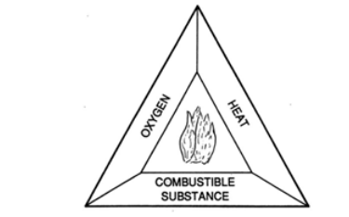

The fire triangle is a useful concept for understanding how fires start and how to prevent them.
By understanding the three elements of fire, you can take steps to remove one or more of them and prevent a fire from starting.

The Fire Tetrahedron:
The fire triangle is a simplified model of fire.
A more complete model, called the fire tetrahedron, includes a fourth element: a chemical chain reaction.

The chemical chain reaction is the process by which the heat from the fire causes the fuel to break down into smaller molecules, which then react with oxygen to create more heat.
This process continues as long as the fire triangle is present.

The fire tetrahedron is a more accurate model of fire, but it is also more complex.
The fire triangle is a good starting point for understanding fire, but the fire tetrahedron is a more complete model that can be used to understand more complex fires.

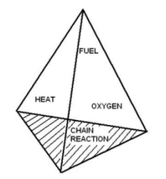
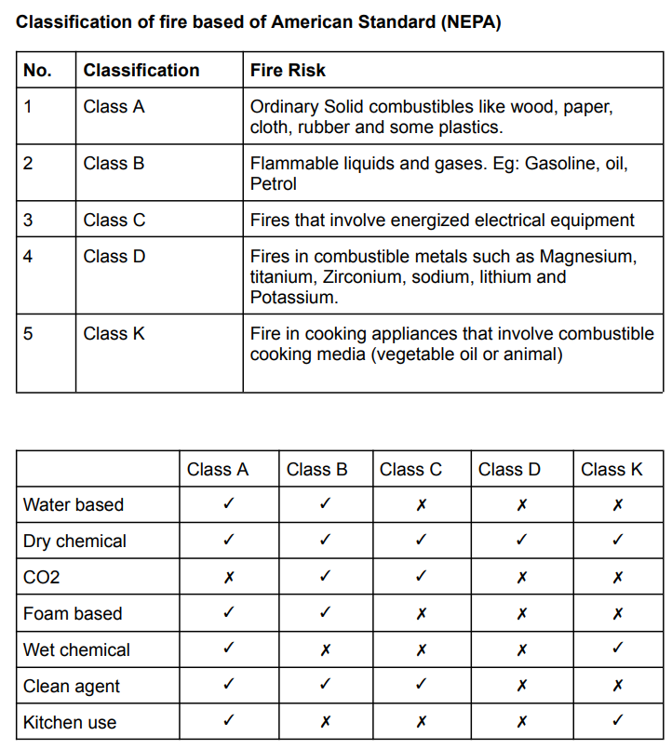

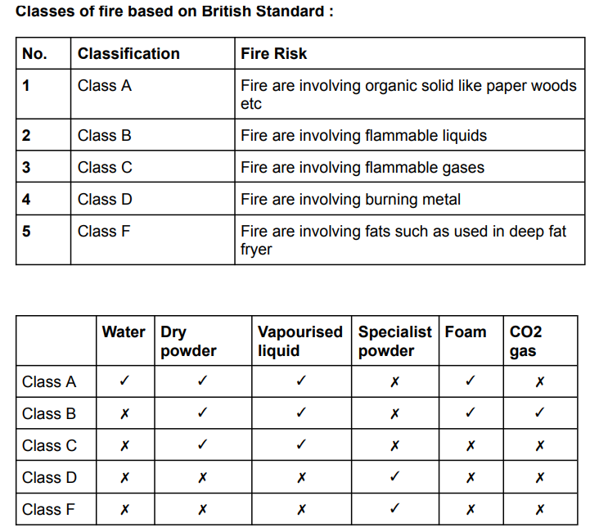
G. Apparatus / Resources Required:
- Fire triangle chart
- Fire class chart
- Sample extinguishers (dummy models)
- Observation sheet
H. Safety and Precautions:
- Do not experiment with real fire without supervision.
- Never use water on electrical or oil fires.
- Handle extinguishers carefully.
- Keep flammable materials away from heat sources.
- Follow emergency procedures and evacuation rules.
I. Procedure:
- Study the fire triangle chart.
- Identify each component: heat, fuel, oxygen.
- Observe and explain how removing one component extinguishes fire.
- Study the chart showing classes of fire.
- Identify each class based on fuel type.
- Match each fire class with its suitable extinguisher.
- Record observations.
J. Observation:
During the practical, the fire triangle was demonstrated by explaining heat, fuel and oxygen as essential fire elements. Different classes of fire were identified along with examples of solid, liquid, gas and electrical fires. Suitable extinguishing methods were discussed for each class. It was observed that fire can be controlled by removing any one element of the fire triangle.
K. Interpretation of Result:
The practical showed that understanding the fire triangle is important to prevent and control fires. Knowing the classes of fire helps select the correct extinguisher and avoid unsafe actions like using water on electrical or oil fires. Recognizing fire types improves safety in industrial environments.
L. Conclusion:
From this practical, it is concluded that understanding the fire triangle is essential for preventing and controlling fires. Heat, fuel, and oxygen are the three basic elements required for fire, and removing any one of them can extinguish it. The study of different classes of fire helped in identifying the type of fuel involved and the correct method of extinguishing each fire class. This knowledge is crucial to avoid using the wrong extinguisher, which can increase danger, especially in electrical or flammable liquid fires. Overall, the practical enhanced awareness of fire safety and improved the ability to respond effectively during fire emergencies.
M. Practical Related Quiz:
1. List out classes of fire with examples
Class A – Fires involving solid combustible materials
Examples: Wood, cloth, paper, plastics, rubber
Class B – Fires involving flammable liquids
Examples: Petrol, diesel, paint, solvents, kerosene, alcohol
Class C – Fires involving flammable gases
Examples: LPG, propane, butane, hydrogen gas leaks
Class D – Fires involving combustible metals
Examples: Magnesium, aluminium powder, sodium, potassium
Class E – Electrical fires
Examples: Short-circuits, electrical panels, wiring, transformers
Class F (or K) – Cooking oil and fat fires
Examples: Deep-fryer oil, vegetable oils, animal fats
2. Explain Fire Tetragon
The Fire Tetragon (also called the fire tetrahedron) is an extended version of the fire triangle.
It explains that four elements are necessary for a fire to start and continue:
- Heat – ignition energy
- Fuel – any combustible material
- Oxygen – supports combustion
- Chemical Chain Reaction – continuous chemical reaction that keeps the fire burning
M. Assessment – Rubrics:
Sr No. | Performance Indicators for the PIs | Weightage in % | Actual marks
1 | Understand importance of practical | 20
2 | Prepare report of practical in prescribed format | 30
3 | Solve assignment question | 30
4 | Viva- voce | 20
 | Total | 100

Sign and Date
Practical No.10: Demonstrate construction and working of different fire extinguishers.

- Objective:
The objective of this practical is to study the internal construction and operating principles of different types of fire extinguishers such as water, foam, CO₂, dry chemical powder, and clean agent extinguishers. Students learn how each extinguisher works, its applications, limitations, and the correct method of operation during fire emergencies.
B. Expected Program Outcomes (POs):
1. Basic and Discipline Specific Knowledge: Apply knowledge of chemical engineering and safety management principles to understand the role of national and international safety standards in industrial operations.
2. Problem Analysis: Identify and analyse industrial safety issues by referring to relevant safety codes and standard practices.
3. Design/Development of Solutions: Design safe and reliable operating procedures and systems based on Indian and international safety standards to prevent accidents and ensure compliance.
4. Environment and Sustainability: Understand environmental safety standards and implement sustainable industrial practices according to ISO 14001 and national environmental laws.
5. Engineering practices for society, sustainability and environment: Apply appropriate technology in context of society, sustainability, environment and ethical practices.
6. Project Management: Use engineering management principles individually, as a team member or a leader to manage projects and effectively communicate about well-defined engineering activities.
7. Life-long learning: Ability to analyse individual needs and engage in updating in the context of technological changes in the field of engineering.
C. Expected skill to be developed based on Competency:
Use principles of safety & pollution control to operate plants safely, and control pollution within permissible limits in chemical industries.
1. Better communication skill
2. Team work
3. Administrative abilities.
D. Expected Course Outcomes:
CO2: Explain Indian and International Safety standards Practical Outcome:
E. Practical Outcome:
Prepare a chart of Indian and International Safety Standards
F. Prerequisite Theory:
A portable fire extinguisher is a lightweight, manually operated device designed to control and extinguish small, incipient-stage fires. It contains an extinguishing agent that can be discharged under pressure and it is portable because it can be easily carried and operated by one person.
Types (with capacity & height)
Water (stored pressure) → Capacity: 12–15 kg
Height: 600–650 mm
Foam (AFFF) → Capacity: 12–15 kg
Height: 600–650 mm
Dry chemical → Capacity: 4–6 kg
Height: 400–500 mm
CO₂ type → Capacity: 2 kg
Height: 450–500 mm
Wet chemical → Capacity: 8–10 kg
Height: 500–600 mm

Classification of Fire Extinguishers
1. Based on operation type
2. Based on extinguishing agent

Based on Operation Type
1. Stored Pressure Type
This type of hand fire extinguisher has a 2½-gallon capacity and a 2A fire rating.
Since it uses fresh water, it must be stored above 40°F, although an antifreeze model is available for use in temperatures as low as –40°F.
The extinguisher weighs about 30 lb and can project a solid water stream 35 to 40 ft horizontally. Pressure and agent are in the same container.
It can be used intermittently, but under continuous operation it discharges for about 55 seconds.
To prevent accidental use, the operating lever is secured with a safety pin or lock which must be pulled out before use.
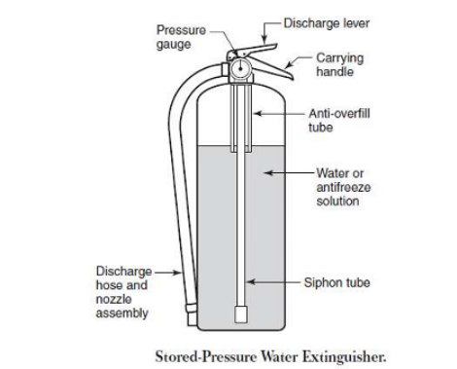
2. Cartridge Type
In cartridge-operated models, the expellant gas is stored in a separate cartridge and could be stored in an expellant gas cylinder located within or adjacent.
The expellant gas then expels the agent. In most models, the discharge can be controlled by a shut-off valve or nozzle.
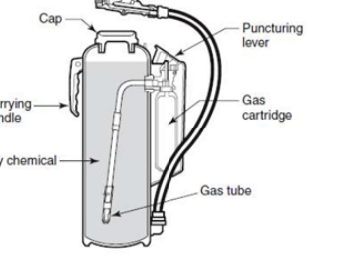

PASS Method
The PASS method is a simple and easy-to-remember technique for using a fire extinguisher.
Steps to operate a fire extinguisher using PASS:
1. P – Pull the pin
Pull the pin on the fire extinguisher. This will break the safety seal and allow the extinguisher agent to be discharged.
2. A – Aim low
Aim the nozzle of the extinguisher at the base of the fire. This is the most effective way to extinguish the fire.
3. S – Squeeze the handle
Squeeze the handle of the extinguisher to discharge the extinguishing agent.
4. S – Sweep
Sweep the nozzle from side to side, keeping the base of the fire in the centre of the fire stream. Continue sweeping until the fire is extinguish.

Based on Extinguishing Agent
1. Water Type Fire Extinguishers
The most popular type is the 2½-gallon (9.46L) stored pressure water fire extinguisher.
An important feature is the ability to be discharged intermittently.
Some models are suitable for use at freezing conditions when charged as specified on the nameplate.

2. AFFF and FFFP Fire Extinguishers
AFFF (Aqueous Film Forming Foam) and FFFP (Film Forming Fluro protein) extinguishers are rated for use on both Class A and B fires.
Not suitable for freezing temperatures.
Advantage: useful on Class B flammable liquid fires because the foam forms a film that floats on and seals the liquid surface, preventing re-ignition.

3. Carbon Dioxide (CO₂) Fire Extinguishers
Main advantage: the agent does not leave any residue after use—important for delicate and costly equipment.
Typical applications: food preparation areas, laboratories, and printing/duplicating areas.
Listed for Class B and C fires.
CO₂ is discharged as a cloud of gas/snow with a short range of 3–8 ft. Not recommended outdoors in windy conditions since the agent dissipates quickly.

4. Dry Chemical Fire Extinguishers
Available in two basic styles: stored-pressure and cartridge-operated.
Stored-pressure type is most widely used and best for infrequent use or where trained personnel are available.
Cartridge-operated type allows quick refilling in remote locations without special equipment.
Many types of dry chemical agents exist; each has advantages and disadvantages.
Potassium and urea-potassium bicarbonate agents are preferred to sodium bicarbonate due to superior extinguishing capability.
Potassium chloride can also be used but is corrosive.

5. Halogenated Agent Extinguishers
Halon fire extinguishers use a halogenated agent to extinguish fires.
Halogens are elements such as fluorine, chlorine, bromine, and iodine. They work by interrupting the chemical reaction necessary for combustion by reacting with free radicals produced during the fire.
Halogenated extinguishers are effective for Class A, B, and C fires.
They are non-conductive, making them safe on electrical fires. However, they are harmful to the environment and have been banned in many countries.
G. Apparatus / Resources Required:
- Water extinguisher
- Foam extinguisher
- DCP extinguisher
- CO₂ extinguisher
- Fire extinguisher cut-section models
- Safety chart
H. Safety and Precautions:
- Do not operate extinguishers without supervision.
- Never use water on electrical or flammable liquid fires.
- CO₂ extinguishers should not be held by the horn due to frostbite risk.
- Check pressure gauge before using stored-pressure extinguishers.
- Maintain safe distance while discharging extinguishers.
I. Procedure:
- Observe the construction of each fire extinguisher.
- Identify main components (cylinder, valve, hose, pressure gauge).
- Note the extinguishing agent used in each extinguisher.
- Study the working mechanism demonstrated by the instructor.
- Match each extinguisher with its suitable fire class.
- Record all observations in the manual.
J. Observation:
During the practical, different fire extinguishers were studied, including water, foam, DCP, CO₂, and wet chemical extinguishers. The construction of each extinguisher was observed along with its extinguishing agent. The working principle of each type was explained based on the fire tetrahedron. Each extinguisher was matched with the appropriate class of fire.
K. Interpretation of Result:
The practical demonstrated that different fire extinguishers are designed for specific fire classes and operate on different extinguishing mechanisms such as cooling, smothering, and interrupting the chain reaction. Understanding their construction and working is essential for effective fire control in emergencies.
L. Conclusion:
This experiment gave practical exposure to the internal construction and functioning of fire extinguishers such as CO₂, foam, DCP, and water extinguishers. It strengthened the ability to select and operate the correct extinguisher during fire emergencies.
M. Practical Related Quiz:
1. Explain PASS Method
The PASS Method is the standard and simplest technique used to operate a fire extinguisher safely.
P – Pull
Pull the safety pin located at the top of the extinguisher.
This unlocks the handle.
A – Aim
Aim the nozzle or hose at the base of the fire, not at the flames.
S – Squeeze
Squeeze the handle/lever to discharge the extinguishing agent.
S – Sweep
Sweep the nozzle side to side at the base of the fire until it is completely extinguished.
PASS = Pull – Aim – Squeeze – Sweep
2. Classify Fire Extinguishers According to Fire Classes
Fire extinguishers are selected based on the class of fire they can extinguish:
1. Water Extinguisher
Suitable for:
- Class A (Solid combustibles: wood, paper, cloth)
2. Foam (AFFF) Extinguisher
Suitable for:
- Class A
- Class B (Flammable liquids: petrol, kerosene)
3. Dry Chemical Powder (DCP) Extinguisher
Suitable for:
- Class A
- Class B
- Class C (Flammable gases)
- Class E (Electrical fires)
4. Carbon Dioxide (CO₂) Extinguisher
Suitable for:
- Class B (Flammable liquids)
- Class E (Electrical fires)
5. Wet Chemical Extinguisher
Suitable for:
- Class F (Cooking oils and fats)
6. Metal Powder Extinguisher
Suitable for:
- Class D (Combustible metals: magnesium, sodium)
N. Assessment – Rubrics:
Sr No. | Performance Indicators for the PIs | Weightage in % | Actual marks
1 | Understand importance of practical | 20
2 | Prepare report of practical in prescribed format | 30
3 | Solve assignment question | 30
4 | Viva- voce | 20
 | Total | 100

Sign and Date

Practical No.11: Apply HAZOP (Hazard Operability Study) method using a case study

A. Objective:
The objective of this experiment is to apply the HAZOP (Hazard and Operability) study method to a selected case-study process in order to systematically identify potential hazards and operational problems. By examining each process step using standard guide-words, the study aims to detect possible deviations, determine their causes, evaluate the likely consequences, and suggest suitable corrective actions or safeguards. This helps in improving the overall safety, reliability, and operability of the process while providing hands-on understanding of industrial risk-assessment techniques.
B. Expected Program Outcomes (POs):
1. Basic and Discipline Specific Knowledge: Apply knowledge of chemical engineering and safety management principles to understand the role of national and international safety standards in industrial operations.
2. Problem Analysis: Identify and analyse industrial safety issues by referring to relevant safety codes and standard practices.
3. Design/Development of Solutions: Design safe and reliable operating procedures and systems based on Indian and international safety standards to prevent accidents and ensure compliance.
4. Environment and Sustainability: Understand environmental safety standards and implement sustainable industrial practices according to ISO 14001 and national environmental laws.
5. Engineering practices for society, sustainability and environment: Apply appropriate technology in context of society, sustainability, environment and ethical practices.
6. Project Management: Use engineering management principles individually, as a team member or a leader to manage projects and effectively communicate about well-defined engineering activities.
7. Life-long learning: Ability to analyse individual needs and engage in updating in the context of technological changes in the field of engineering.
C. Expected skill to be developed based on Competency:
Use principles of safety & pollution control to operate plants safely, and control pollution within permissible limits in chemical industries.
1. Better communication skill
2. Team work
3. Administrative abilities.
D. Expected Course Outcomes:
CO4: Explain hazard identification method & Risk assessment method
E. Practical Outcome:
Apply HAZOP (Hazard Operability Study) method using a case study.
F. Prerequisite Theory:
Hazards and operability (HAZOP) studies Structured and systematic examination of a planned or existing process / operation in order to identify and evaluate problems that may represent risks to personnel or equipment, or prevent efficient operation. Used for many years as a formal procedure to identify hazards in a chemical process facility. Systematic search for hazards which are defined as deviations within these parameters that may have dangerous consequences. HAZOP is a team approach, involving a team of people representing all different functions in a plant. They identify all the deviations by “brain storming" to a set of guide words which is applied to all parts of the system. The process is systematic and it is helpful to define the terms that are used:
● Study Nodes: The locations (on piping and instrumentation drawings and procedures) at which the process parameters are investigated for deviations.
● Intention: The intention defines how the plant is expected to operate in the absence of deviations at the study nodes. This can take a number of forms and can either be descriptive or diagrammatic; e.g., flowsheets, line diagrams, P&IDs. 2 Safety and Hazard Management (DI03005051)
● Deviations: These are departures from the intention which are discovered by systematically applying the guide words (e.g., “more pressure”).
● Causes: Reasons why deviations might occur. Once a deviation has been shown to have a credible cause, it can be treated as a meaningful deviation. These causes can be hardware failures, human errors, an unanticipated process state (e.g., change of composition), external disruptions (e.g., loss of power), etc.
● Consequences: Results of deviations should they occur (e.g., release of toxic materials).
● Guide Words: Simple words which are used to qualify or quantify the intention in order to guide and stimulate the brainstorming process and so discover deviations. Guidewords in HAZOP Guidewords are standard keywords used to generate deviations from normal operation. Based on the images provided, commonly used guidewords include:
● NO / NOT – The complete absence of the intended operation (e.g., no flow due to pump failure or closed valve).
● MORE / LESS – A quantitative increase or decrease in parameters such as flow, temperature, level, or pressure (e.g., more flow due to a fully open valve).
● AS WELL AS – Something additional occurs along with the intended function (e.g., air entering the system along with liquid).
● PART OF – Only part of the intended operation occurs (e.g., partial flow due to a blocked line).
● REVERSE – The opposite of the intended operation occurs (e.g., liquid flowing backwards due to wrong connection).
● OTHER THAN – Something completely different from the design intent happens (e.g., boiling in a pump because of high temperature)
HAZOP STUDY FOR CHEMICAL REACTOR
A batch chemical reactor in which a polymerization reaction takes place in liquid phase. Initially a fixed quantity of reactant A called starter along with liquid catalyst is added to the reactor and the reactor contains a well-mixed mixture and is heated to a polymerization temperature of 125°C. When the required temperature is reached, the reactant B is added continuously. Since the volume of the reactor is fixed, the flow of reactant B is stopped when the required quantity of B has been fed. The polymerization reaction is exothermic and heat generated is removed by circulating the liquid through a heat exchanger as shown. After the batch is completed, the reactor products are transferred to another vessel for removal and further processing.

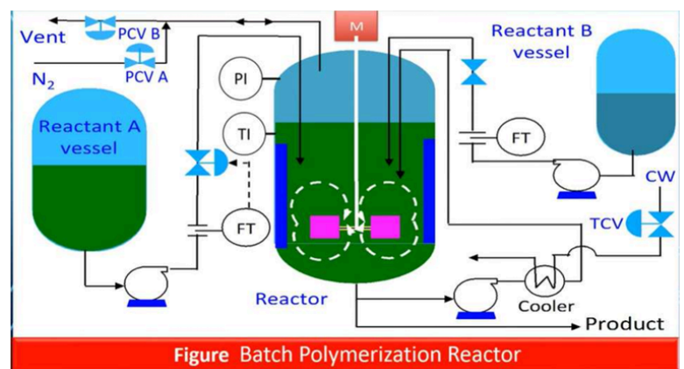
G. Apparatus / Resources Required:
- P&ID or simplified process flow diagram for the case study
- Safety Data Sheet (SDS) for xylene
- HAZOP worksheet (printed or spreadsheet)
- Calculator, pen, highlighter
H. Procedure:
- Form HAZOP team: facilitator, process engineer, operations rep, I&C engineer, safety officer, scribe.
- Define nodes for study (e.g., Tank T-101, Transfer line L-101, Pump P-101, Reactor R-201 inlet).
- For each node, state the design intent.
- Apply guide-words to parameters (flow, level, pressure, composition, temperature).
- For every deviation, record: possible causes, possible consequences, existing safeguards, recommended actions, risk ranking, action owner and target date.
- Review and finalise worksheet; assign responsibilities; follow-up until closure
I. Observation:
During the HAZOP study of the xylene storage and transfer system, various deviations such as no flow, high flow, reverse flow, low level and high pressure were identified. Each deviation was examined using guide-words, and possible causes like pump failure, valve misalignment, instrument faults and equipment blockage were observed. The consequences included reactor overfilling, leakage, contamination and potential fire hazards. Existing safeguards such as alarms, SOPs and relief valves were recognized, and several improvements were noted as necessary. The worksheet helped clearly document hazards, controls and corrective actions.
J. Interpretation of Result:
From the HAZOP study, it is interpreted that the xylene storage and transfer system contains several potential deviations that could lead to unsafe operating conditions. By applying guide-words systematically, the team was able to identify credible causes such as pump failure, instrument malfunction, incorrect valve positions and contamination risks. The consequences of these deviations showed possibilities of spills, overfilling, high-pressure situations and fire hazards. Existing safeguards helped reduce risk, but additional recommendations like interlocks, improved labelling and redundant sensors were identified to further enhance safety. Overall, the HAZOP analysis provided a structured understanding of process risks and highlighted the importance of implementing corrective actions to maintain safe and reliable plant operation.
K. Conclusion:
The HAZOP study conducted on the xylene storage and transfer system helped identify several operational and safety-related deviations that could lead to hazardous conditions. By applying guide-words and analysing each deviation, the team understood the root causes, consequences, existing safeguards and areas needing improvement. The study clearly showed that systematic hazard identification and detailed documentation greatly enhance plant safety and operability. Implementing the recommended actions—such as adding interlocks, strengthening procedures and improving instrumentation—will reduce risks to acceptable levels. Overall, the HAZOP exercise proved to be an effective tool for preventing accidents and ensuring safer chemical plant operations.
L. Practical Related Quiz:
1. Define Study Nodes, Intention, Deviation, Parameter and Guide Words.
Study nodes are specific sections of a process selected for HAZOP analysis. Each node represents a part of the plant where process conditions (flow, level, pressure, temperature, etc.) are expected to be uniform.
The intention is the purpose or normal operating objective of a process node. It describes what the system is designed to do under normal conditions.
A deviation is any departure from the design intent. It represents an abnormal condition discovered by combining guide words with process parameters.
Parameters are measurable or controllable process variables used in HAZOP to detect abnormal conditions.
Guide words are standard keywords used in HAZOP to systematically generate deviations. They are applied to process parameters to identify abnormal situations.
2. Define HAZOP Studies
HAZOP (Hazard and Operability) study is a structured and systematic method used to identify hazards and operational problems in process plants. It uses guide words and parameters to evaluate deviations from design intent, determine causes and consequences, identify existing safeguards, and recommend corrective actions to improve plant safety and operability.

M. Assessment – Rubrics:
Sr No. | Performance Indicators for the PIs | Weightage in % | Actual marks
1 | Understand importance of practical | 20
2 | Prepare report of practical in prescribed format | 30
3 | Solve assignment question | 30
4 | Viva- voce | 20
 | Total | 100

Sign and date

Practical No.12: Apply Risk Assessment methods (FTA, ETA) for a chemical plant

  - Objective:
The objective of this experiment is to analyse the potential hazards in a chemical plant by applying Fault Tree Analysis (FTA) and Event Tree Analysis (ETA), in order to identify root causes of failures, evaluate possible accident outcomes, and develop effective risk-reduction measures.
B. Expected Program Outcomes (POs):
1. Basic and Discipline Specific Knowledge: Apply knowledge of chemical engineering and safety management principles to understand the role of national and international safety standards in industrial operations.
- Problem Analysis: Identify and analyse industrial safety issues by referring to relevant safety codes and standard practices.
3. Design/Development of Solutions: Design safe and reliable operating procedures and systems based on Indian and international safety standards to prevent accidents and ensure compliance.
4. Environment and Sustainability: Understand environmental safety standards and implement sustainable industrial practices according to ISO 14001 and national environmental laws.
5. Engineering practices for society, sustainability and environment: Apply appropriate technology in context of society, sustainability, environment and ethical practices.
6. Project Management: Use engineering management principles individually, as a team member or a leader to manage projects and effectively communicate about well-defined engineering activities.
7. Life-long learning: Ability to analyse individual needs and engage in updating in the context of technological changes in the field of engineering.
C. Expected skill to be developed based on Competency:
Use principles of safety & pollution control to operate plants safely, and control pollution within permissible limits in chemical industries.
1. Better communication skill
2. Team work
3. Administrative abilities.
D. Expected Course Outcomes:
CO4: Explain hazard identification method & Risk assessment method
E. Practical Outcome:
Apply Risk Assessment methods (FTA, ETA) for a chemical plant.
F. Prerequisite Theory:
Fault Tree Analysis
● In many cases there are multiple causes for an accident or other loss-making event.
● Fault tree analysis is one analytical technique for tracing the events which could contribute to an accident or other loss-making event.
● It can be used in accident investigation and in a detailed hazard assessment.
● The fault tree is a logical diagram based on the principle of multi-causality which traces all branches of events which could contribute to an accident or failure.
● It uses a set of symbols, labels and identifiers.

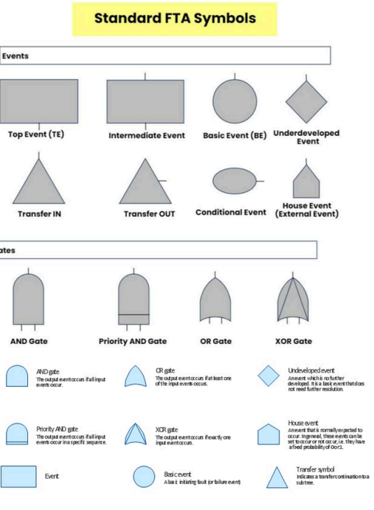

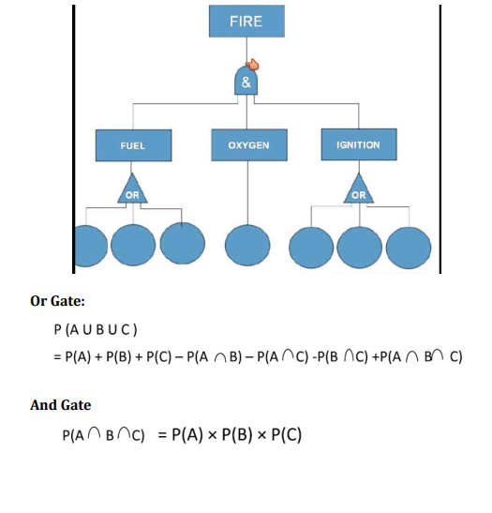

Question 1. What do you understand about the term “FTA”?
Fault Tree Analysis (FTA) is a top-down, deductive risk analysis technique used to determine the possible combinations of component failures, human errors or external events that can lead to a specified undesired event (called the top event).
2. Conduct fault tree analysis for a fire accident in industry. The values given are:
● Solid – 4%
● Liquid – 8%
● Gases – 13%
● Spark – 7%
● Misuse – 13%
● Flames – 20%
● Atmospheric air – 100%

G. Apparatus / Resources Required:
- P&ID (Piping and Instrumentation Diagram) of the selected chemical process
- Process Flow Diagram (PFD)
- Safety Data Sheet (SDS) of the chemical used in the case study
- HAZOP / FTA / ETA worksheet sheets (printed format)
- Fault Tree templates (branch symbols, AND/OR gate symbols)
- Event Tree templates (success/failure branch charts)
- Calculator for probability calculations
- Marker pens, pencil, eraser, scale
- Notebook or observation sheet for recording deviations
- Computer/Laptop (optional) for drawing digital fault trees and event trees
- Instructor demonstration material for gates, event sequences and failure modes
H. Safety and Precautions:
- Carefully study the P&ID and process description before performing the risk assessment.
- Ensure that all assumptions used in FTA and ETA are based on correct process data.
- Avoid using unrealistic or exaggerated failure probabilities; follow standard values provided by the instructor.
- Do not perform any real operational changes on plant equipment during the assessment.
- While discussing failure scenarios, avoid creating confusion in the actual control room environment.
- Maintain accuracy when drawing AND/OR gates or success–failure branches, as wrong diagrams may lead to incorrect conclusions.
I. Procedure (Steps to perform FTA & ETA):
- Select a realistic scenario (top event or initiating event).
- Gather system data: P&ID, protection systems, instrumentation, SOPs.
- For FTA: define top event, identify immediate causes, build tree using AND/OR gates down to base events. Determine minimal cut sets. Optionally assign probabilities to base events.
- For ETA: choose initiating event, list important success/failure branches (detection, isolation, ignition, suppression), draw branches and compute end-state probabilities.
- Analyse results: identify dominant contributors, compute top event probability (illustrative), propose controls, prioritize actions.
- Document results (worksheets, recommendations, owners, deadlines).
J. Observations:
• FTA pinpoints combinations of equipment and human failures that lead to a top event (e.g., detection failure + ignition + release).
• ETA quantifies how protective layers (detection, isolation, suppression) reduce consequences and shows the relative worth of each barrier.
K. Interpretation of Results:
• The dominant contributors to risk in the case study are failures in early detection and isolation (single points of failure) and the presence of ignition sources.
• Reducing the probability of pump seal failure, increasing detection reliability, ensuring robust automatic isolation and improving suppression reliability substantially lower the likelihood of catastrophic outcomes.
• FTA helps identify minimal cut sets to prioritize mitigation; ETA shows which safety layers give best risk reduction per investment.
L. Conclusion:
Applying FTA and ETA to the selected chemical plant scenario helped identify critical combinations of failures that can lead to major incidents and demonstrated how protective layers reduce consequences. The analyses (qualitative and illustrative quantitative) show that targeted improvements — especially in detection and automatic isolation — yield significant risk reductions. Regular updating of fault trees/event trees with plant-specific failure data is recommended to maintain accurate risk profiles and to prioritize investments.
M. Practical Related Quiz:
1. List out Standard FTA Symbols
These are the commonly accepted Fault Tree Analysis symbols:
Gate Symbols
- AND Gate (⋀) – Top event occurs only if all input events occur.
- OR Gate (⋁) – Top event occurs if any one of the input events occur.
- Priority AND Gate – Output occurs only if events happen in a specific order.
- Inhibit Gate – Output occurs if the input event happens under an enabling condition.
Event Symbols
- Basic Event – Fundamental failure that requires no further breakdown (circle).
- Intermediate Event – Result of combining lower-level events (rectangle).
- Undeveloped Event – Not analysed further due to lack of data (diamond).
- House Event – An event that is always true or always false (house-shaped symbol).
- Transfer In / Transfer Out – Used to continue the fault tree on another page.
2. Define ETA.
ETA (Event Tree Analysis) is a forward, inductive risk assessment method that evaluates the possible outcomes after an initiating event occurs.
N. Assessment – Rubrics:
Sr No. | Performance Indicators for the PIs | Weightage in % | Actual marks
1 | Understand importance of practical | 20
2 | Prepare report of practical in prescribed format | 30
3 | Solve assignment question | 30
4 | Viva- voce | 20
 | Total | 100

Sign and Date

Practical No.13: analyse a case study of an industry disaster

  - Objective:
The objective of this practical is to study and analyse a real-world industrial disaster such as Bhopal gas tragedy, Flix borough explosion, or Texas refinery explosion. Students examine the causes, consequences, failure points, and lessons learned. The aim is to develop a deeper understanding of the importance of safety management and preventive measures.
B. Expected Program Outcomes (POs):
1. Basic and Discipline Specific Knowledge: Apply knowledge of chemical engineering and safety management principles to understand the role of national and international safety standards in industrial operations.
2. Problem Analysis: Identify and analyse industrial safety issues by referring to relevant safety codes and standard practices.
3. Design/Development of Solutions: Design safe and reliable operating procedures and systems based on Indian and international safety standards to prevent accidents and ensure compliance.
4. Environment and Sustainability: Understand environmental safety standards and implement sustainable industrial practices according to ISO 14001 and national environmental laws.
5. Engineering practices for society, sustainability and environment: Apply appropriate technology in context of society, sustainability, environment and ethical practices.
6. Project Management: Use engineering management principles individually, as a team member or a leader to manage projects and effectively communicate about well-defined engineering activities.
7. Life-long learning: Ability to analyse individual needs and engage in updating in the context of technological changes in the field of engineering.
C. Expected skill to be developed based on Competency:
Use principles of safety & pollution control to operate plants safely, and control pollution within permissible limits in chemical industries.
1. Better communication skill
2. Team work
3. Administrative abilities.
D. Expected Course Outcomes:
CO2: Explain Indian and International Safety standards Practical Outcome
E. Practical Outcome:
Prepare a chart of Indian and International Safety Standards
F. Prerequisite Theory:
Bhopal Gas Tragedy
The worst accident in the history of the chemical industry occurred at the Union Carbide Plant in Bhopal, India on December 3, 1984.
The plant was manufacturing the pesticide Sevin (Carbaryl) using methyl isocyanate (MIC) as an intermediate chemical, a highly toxic and reactive compound.
A highly toxic gas, Methyl Isocyanate (MIC), leaked from a storage tank, exposing over thousands of people to toxic fumes, resulting in thousands of deaths and long-term health issues.
Chronology of Events Leading to the Disaster
At 1998 :The plant was facing financial losses and had cut costs, reducing maintenance and safety staff.
Safety systems such as refrigeration and scrubbers were not in proper working condition.
(Reaction: Monomethylamine + Phosgene → Methyl isocyanate
Methyl isocyanate + Alpha–naphthol → Carbaryl)

December 2, 1984: Around 9:30 PM, workers began routine cleaning of pipes connected to the MIC storage tank.
Due to a faulty valve, water entered the tank, mixing with about 42 tonnes of MIC and initiating an exothermic reaction.
Pressure built up rapidly as the temperature rose.

December 3, 1984 (Around 12:30 AM): Shortly after midnight, the tank’s safety valve ruptured, releasing over 27–30 tons of MIC gas into the atmosphere over 2 hours.

Morning of 3 December: Thousands died due to chemical exposure.

Root Causes of the Disaster
Technical failures: Water entered the MIC tank due to a faulty valve or poor maintenance.
This caused a runaway chemical reaction, producing heat and pressure.

Cost-cutting and poor maintenance: Equipment was corroded and alarms were unreliable due to frequent false triggers.

Design and operational flaws: The plant’s design was imported from the U.S. and not adapted for India’s conditions.
MIC was stored in large quantities (up to 90 tons) instead of smaller batches, violating safety norms.
Lack of computerized monitoring and inadequate emergency protocols.

Human factors: Management ignored prior incidents and union complaints.
Local regulations were lax, and the plant’s hazardous location near populated areas was approved despite risks.
Corporate decisions from Union Carbide’s U.S. headquarters prioritized profits over safety.
Consequences
a) Human Impact
Over 3,000 people died immediately.
Later deaths exceeded 15,000.
Over 50,000 people exposed to toxic gas suffered long-term health issues like respiratory disorders, eye irritation, birth defects, and cancers.

b) Environmental Impact
Soil and groundwater around the plant were contaminated with toxic chemicals.
Long-term ecological damage affected vegetation and animal life.

c) Legal & Social Impact
UCC’s chairman Warren Anderson was arrested but later released on bail.
In 1989, UCC agreed to pay $470 million as compensation, considered insufficient.
The tragedy led to major changes in environmental and industrial safety laws in India.
Key Lessons Learnt
1. Safety should never be compromised for cost-cutting.
2. Proper maintenance and inspection of safety systems are essential.
3. Hazardous materials should be stored in minimal quantities and under controlled conditions.
4. Emergency preparedness and public awareness are crucial in industrial areas.
5. Strict enforcement of industrial safety and environmental laws is mandatory.
G. Safety Lessons Learned:
• Never store large quantities of highly toxic chemicals.
• All safety systems must be functional at all times.
• Regular inspection and maintenance are essential.
• Workers must be well-trained and aware of hazards.
• Strict emergency preparedness and community awareness are required.
• Industries must follow process safety management (PSM) standards.
• Strong legal enforcement and audits prevent negligence.
H. Observation:
During the analysis, it was observed that the tragedy resulted from multiple failures including technical faults, poor maintenance, lack of training, and ignoring safety warnings. Most safety systems were shut down to reduce cost, and emergency response measures were inadequate. This case clearly showed how lack of safety culture can lead to catastrophic consequences.
I. Interpretation of Result:
The study shows that the Bhopal Gas Tragedy was a preventable disaster caused by serious negligence. If proper maintenance, functioning safety systems, and risk management practices were followed, the accident would not have occurred. The incident demonstrates the importance of strict industrial safety standards and responsible management practices.
J. Conclusion :
The case study analysis helped understand real industrial accidents, their root causes, consequences, and lessons learned. It emphasized the importance of strict safety management, regulatory compliance, and continuous improvement in industrial safety.

K. Practical Related Quiz:
1. Chemical Reactions for Manufacturing Carbaryl (Sevin)
Carbaryl is an insecticide manufactured from Methyl Isocyanate (MIC) and 1-Naphthol.
Step 1: Manufacture of Methyl Isocyanate (MIC)
MIC is produced from Phosgene (COCl₂) and Methylamine (CH₃NH₂).
Reaction A – Formation of Methylcarbamoyl Chloride (MCC):
CH3​NH2​+COCl2 ​→ CH3​NHCOCl + HCl
Reaction B – Production of Methyl Isocyanate (MIC):
CH3​NHCOCl→CH3​NCO + HCl

Step 2: Manufacture of Carbaryl
Carbaryl is synthesized by reacting MIC with 1-Naphthol (C₁₀H₇OH).
CH3​NCO+C10​H7​OH→C12​H11​NO2​(Carbaryl)
2. List Out Safety Equipment Malfunction in Bhopal Gas Incident
During the Bhopal Gas Tragedy (1984) at Union Carbide India Ltd., multiple layers of safety equipment were disabled, malfunctioning, or not in operation. Below is the exact list:
Safety Equipment Failures in the Bhopal Disaster
1. Vent Gas Scrubber (VGS) – Not Working
- Designed to neutralize toxic MIC vapours with caustic soda.
- Was shut down or running at very low efficiency.
2. Flare Tower – Non-functional
- Should burn toxic gases during emergency releases.
- Flare pilot flame was OFF due to lack of LPG supply.
3. Refrigeration Unit – Turned Off
- Used to keep MIC at 0°C to prevent runaway reactions.
- MIC was stored at 20–25°C, increasing reaction rate.
4. Temperature & Pressure Alarms – Faulty / Not Responding
- Several alarms in the control room were not working.
- Operators could not detect dangerous conditions early.
5. Water Curtain System – Inadequate Pressure
- Water spray towers meant to absorb MIC vapours.
- Height of spray was too low to reach escaping cloud.
6. MIC Storage Tank Pressure Gauge – Defective
- Gave incorrect readings, misleading operators.
7. Relief Valve Vent Header (RVVH) – Under-maintained
- Corroded, leaking, and not tested regularly.
- Allowed toxic gas to escape directly.
8. Safety & Operating Procedures – Not Followed
- Workers were understaffed and poorly trained.
- Maintenance shortcuts, disabled safety systems.
9. No Emergency Response Plan
- Siren was delayed.
- No evacuation plan or community warning system.
J. Assessment – Rubrics:
Sr No. | Performance Indicators for the PIs | Weightage in % | Actual marks
1 | Understand importance of practical | 20
2 | Prepare report of practical in prescribed format | 30
3 | Solve assignment question | 30
4 | Viva- voce | 20
 | Total | 100

Sign and date

